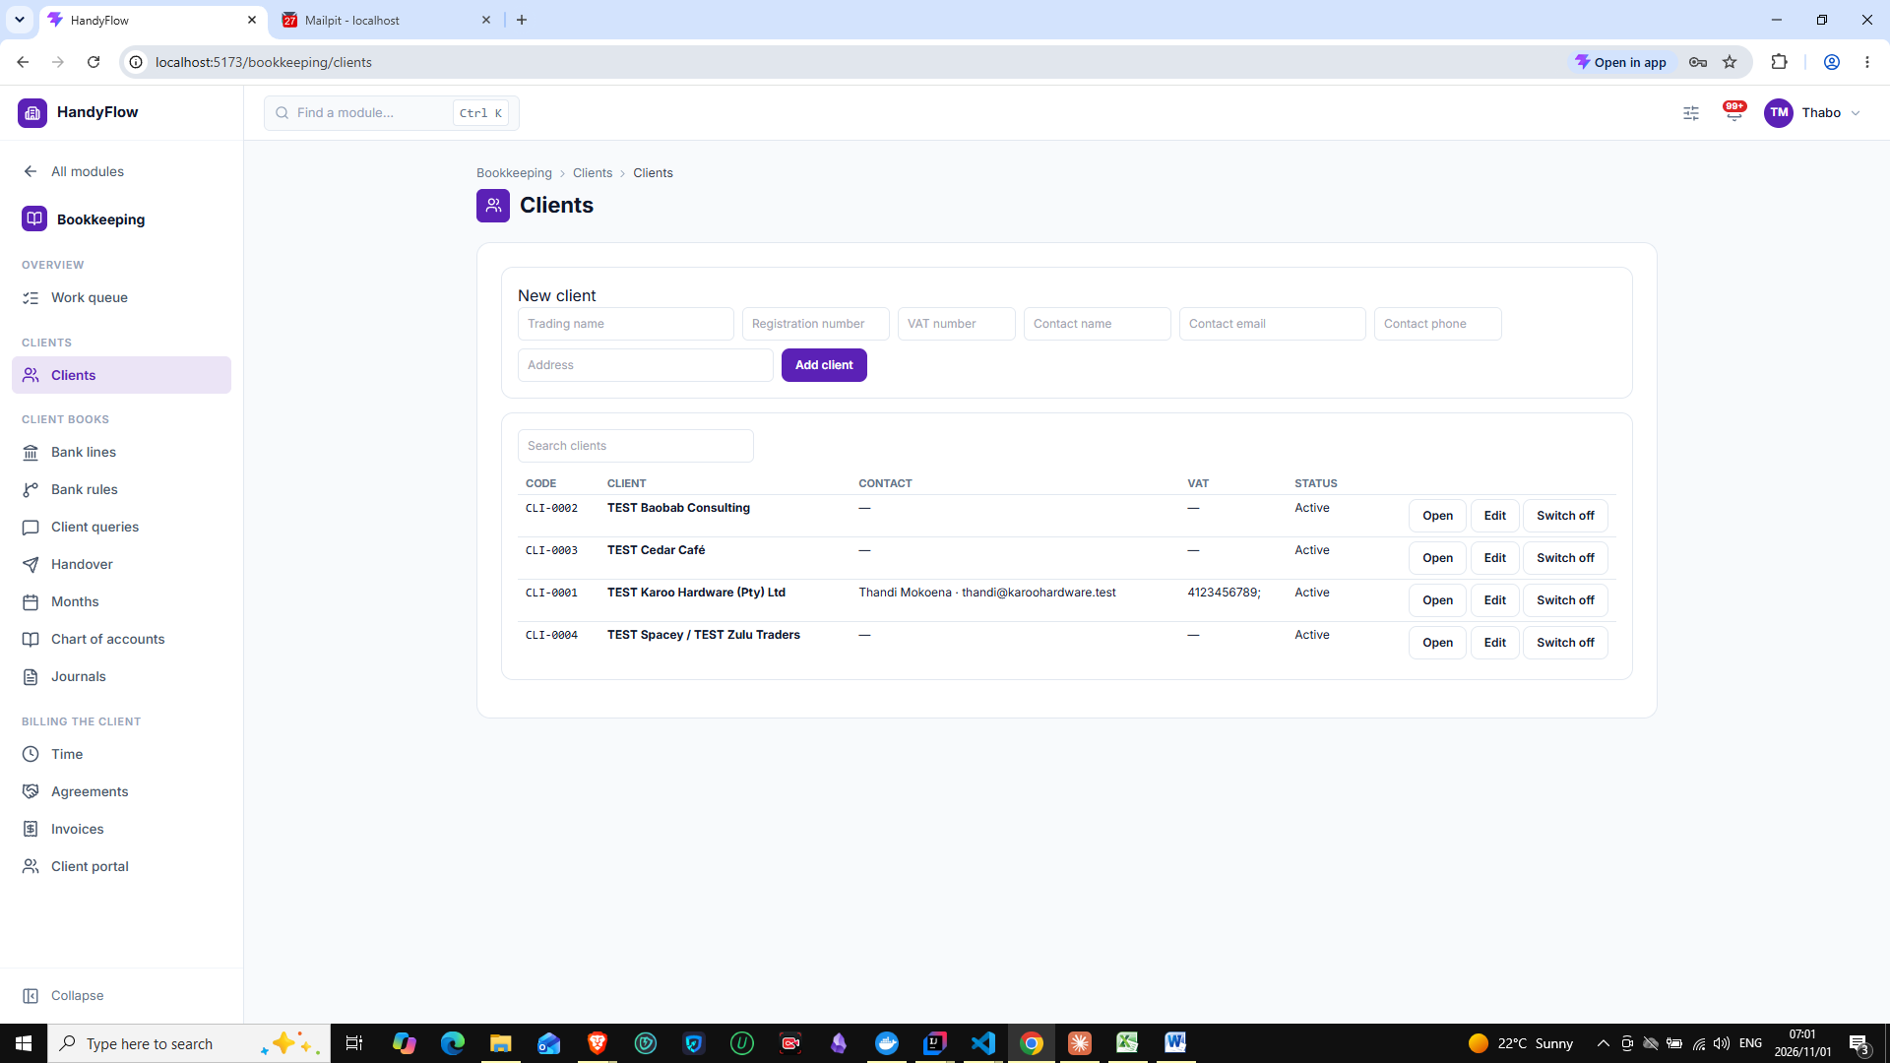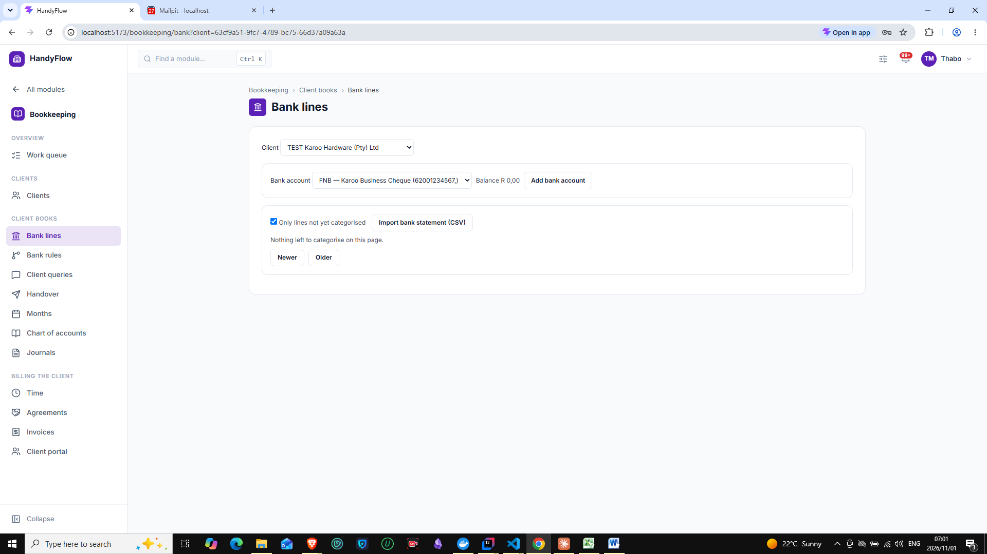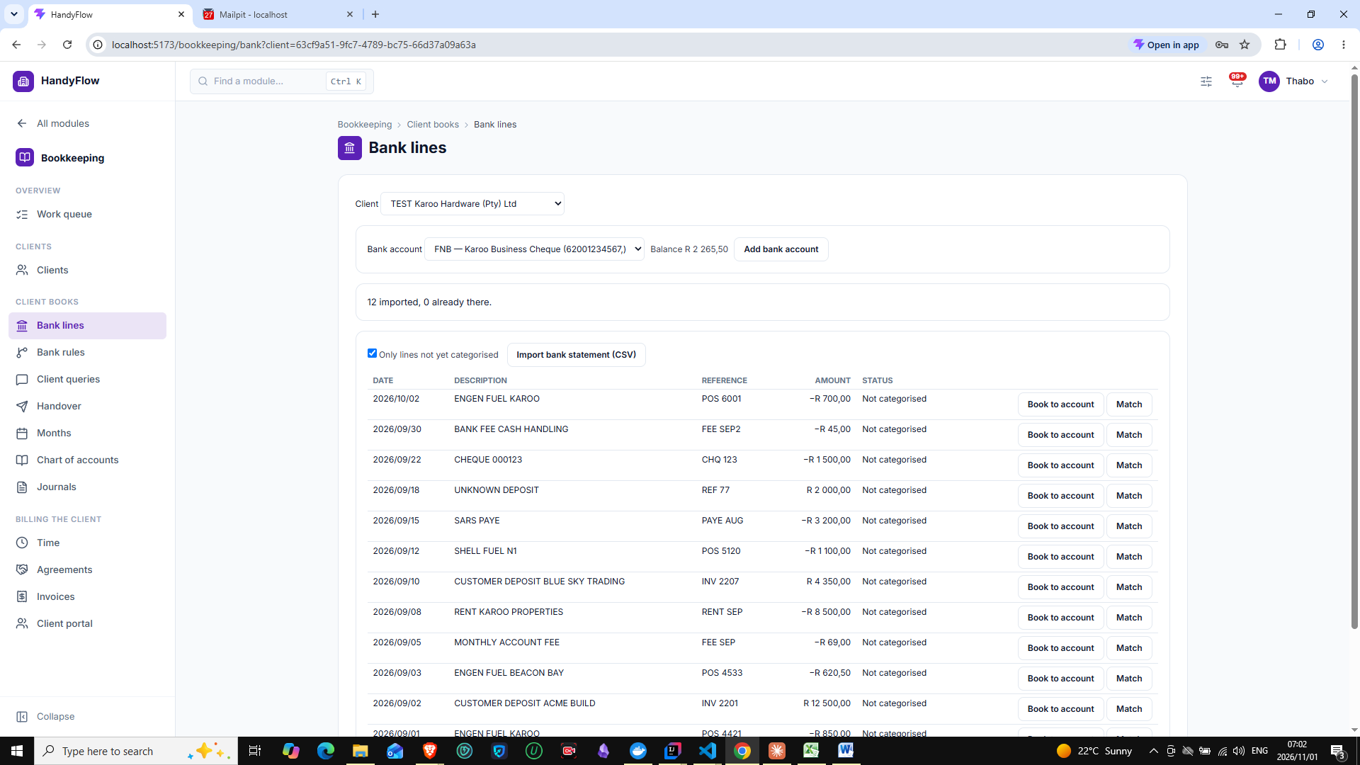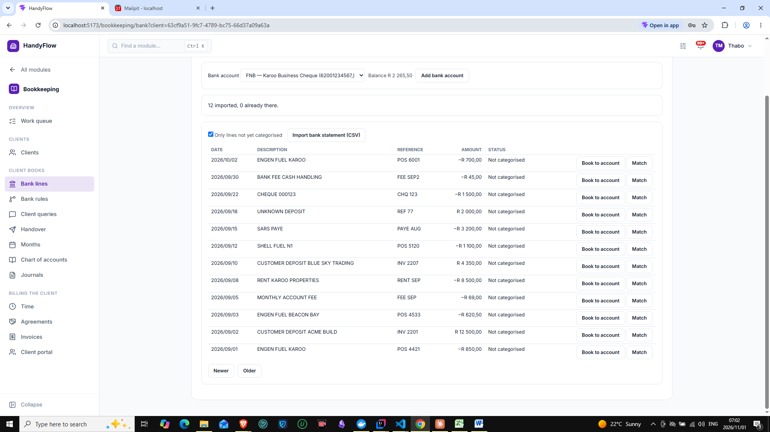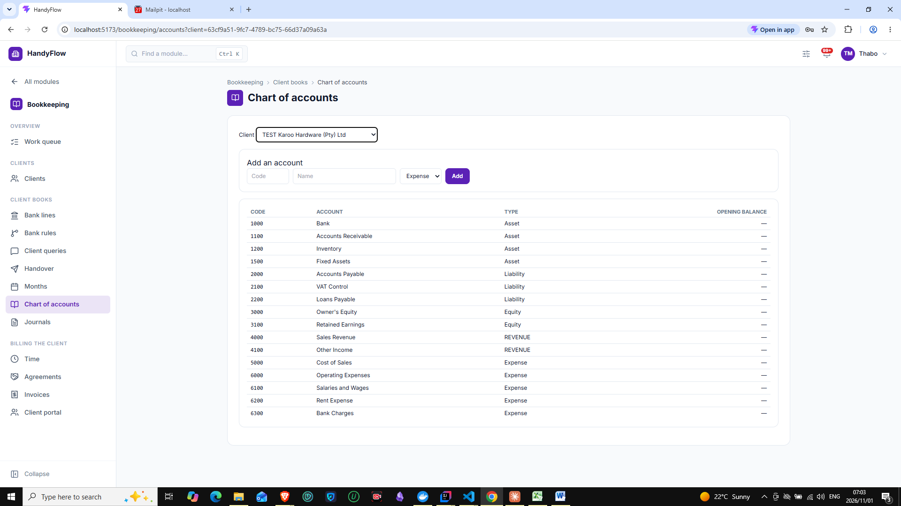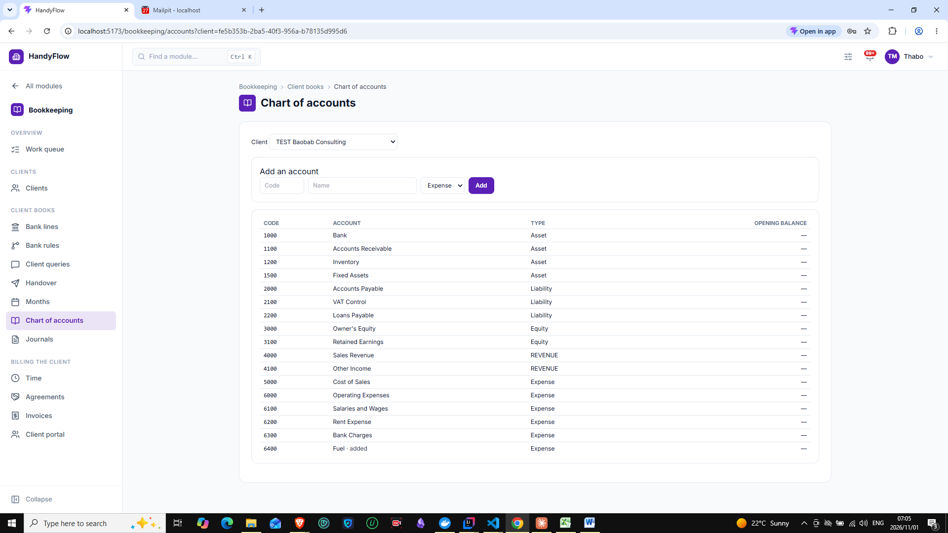
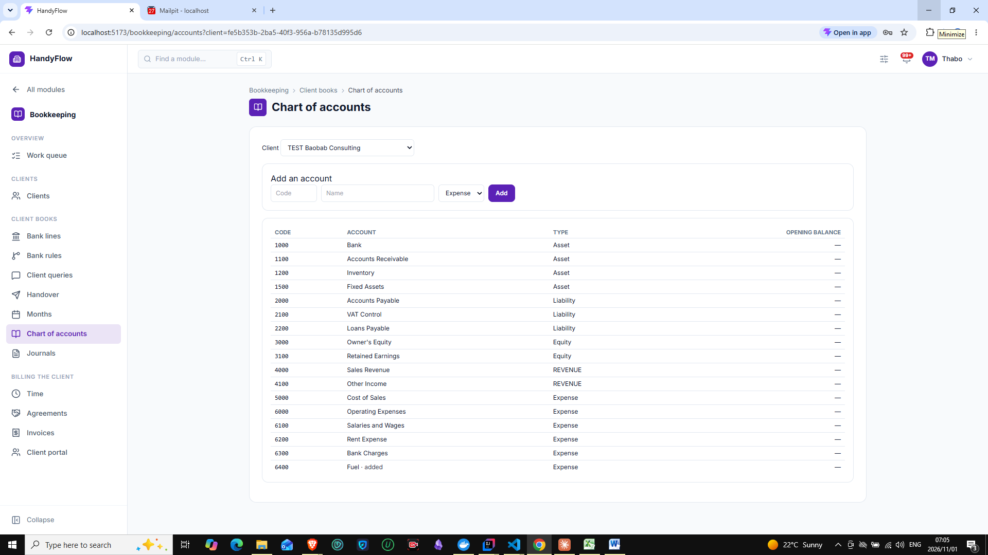
Clicking add with empty fields, nothing happens, no reaction or error shown
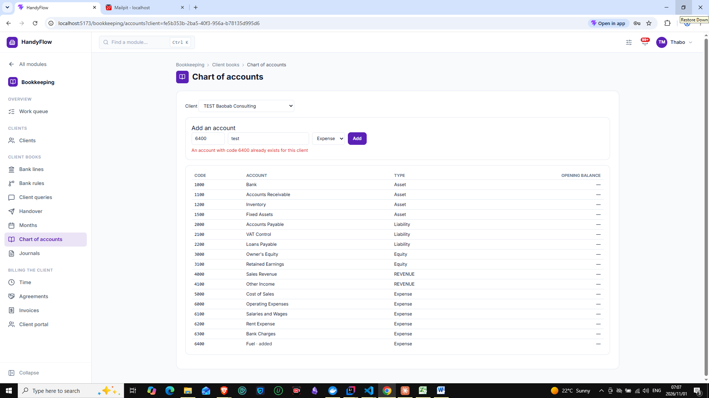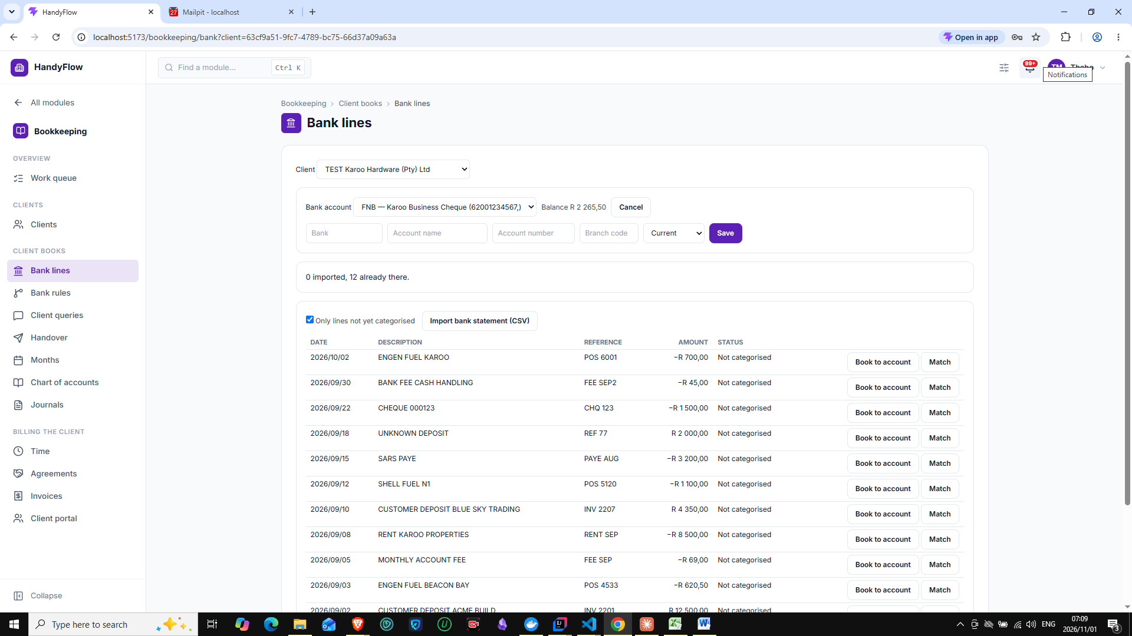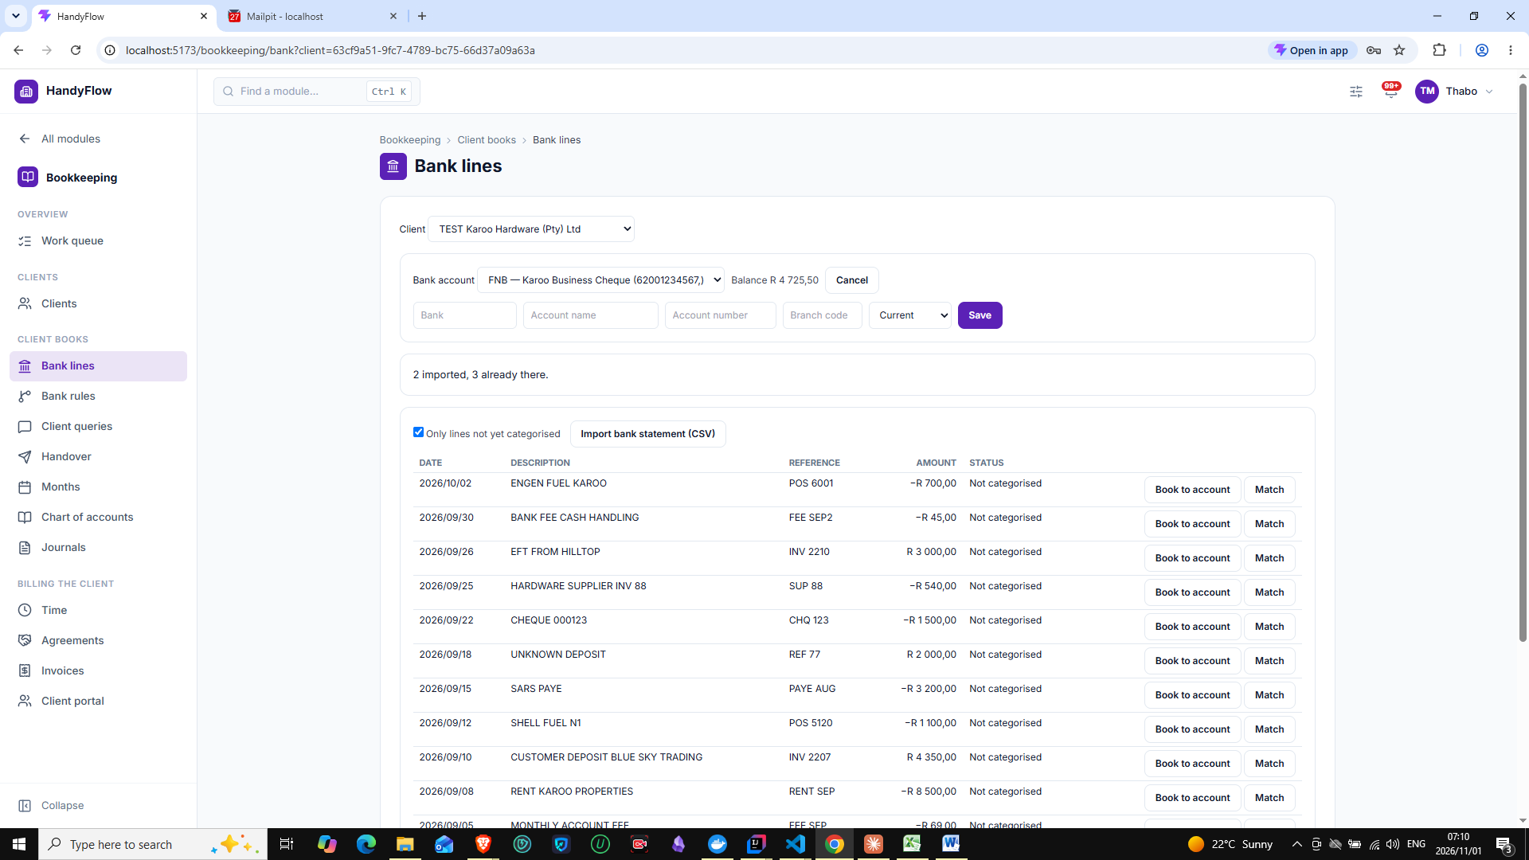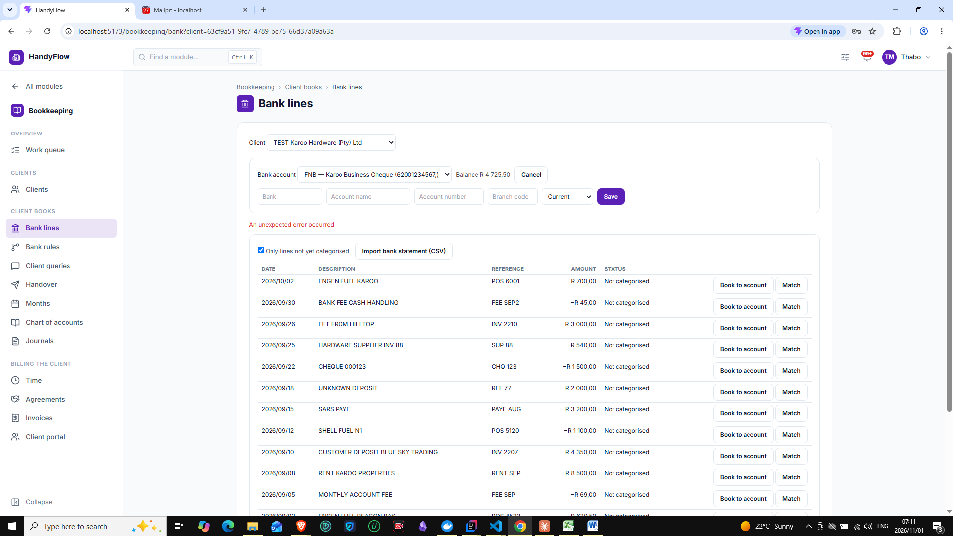
2026-11-01 07:11:16 [http-nio-8080-exec-9] DEBUG [] [] o.s.s.a.m.AuthorizationManagerBeforeMethodInterceptor - Authorized method invocation ReflectiveMethodInvocation: public org.springframework.http.ResponseEntity za.co.handyflow.platform.bookkeeping.api.BkBankTransactionController.importTransactions(java.util.UUID,za.co.handyflow.platform.bookkeeping.dto.ImportBkTransactionsRequest); target is of class [za.co.handyflow.platform.bookkeeping.api.BkBankTransactionController]
2026-11-01 07:11:16 [http-nio-8080-exec-9] ERROR [] [] z.c.h.p.s.GlobalExceptionHandler - Unexpected error
java.time.format.DateTimeParseException: Text '31/09/2026' could not be parsed at index 0
at java.base/java.time.format.DateTimeFormatter.parseResolved0(DateTimeFormatter.java:2108)
at java.base/java.time.format.DateTimeFormatter.parse(DateTimeFormatter.java:2010)
at java.base/java.time.LocalDate.parse(LocalDate.java:435)
at java.base/java.time.LocalDate.parse(LocalDate.java:420)
at za.co.handyflow.platform.bookkeeping.application.internal.BkBankTransactionService.importTransactions(BkBankTransactionService.java:110)
at java.base/jdk.internal.reflect.DirectMethodHandleAccessor.invoke(DirectMethodHandleAccessor.java:103)
at java.base/java.lang.reflect.Method.invoke(Method.java:580)
at org.springframework.aop.support.AopUtils.invokeJoinpointUsingReflection(AopUtils.java:359)
at org.springframework.aop.framework.ReflectiveMethodInvocation.invokeJoinpoint(ReflectiveMethodInvocation.java:196)
at org.springframework.aop.framework.ReflectiveMethodInvocation.proceed(ReflectiveMethodInvocation.java:163)
at org.springframework.transaction.interceptor.TransactionAspectSupport.invokeWithinTransaction(TransactionAspectSupport.java:380)
at org.springframework.transaction.interceptor.TransactionInterceptor.invoke(TransactionInterceptor.java:119)
at org.springframework.aop.framework.ReflectiveMethodInvocation.proceed(ReflectiveMethodInvocation.java:184)
at org.springframework.aop.framework.CglibAopProxy$DynamicAdvisedInterceptor.intercept(CglibAopProxy.java:728)
at za.co.handyflow.platform.bookkeeping.application.internal.BkBankTransactionService$$SpringCGLIB$$0.importTransactions(<generated>)
at za.co.handyflow.platform.bookkeeping.api.BkBankTransactionController.importTransactions(BkBankTransactionController.java:47)
at java.base/jdk.internal.reflect.DirectMethodHandleAccessor.invoke(DirectMethodHandleAccessor.java:103)
at java.base/java.lang.reflect.Method.invoke(Method.java:580)
at org.springframework.aop.support.AopUtils.invokeJoinpointUsingReflection(AopUtils.java:359)
at org.springframework.aop.framework.ReflectiveMethodInvocation.invokeJoinpoint(ReflectiveMethodInvocation.java:196)
at org.springframework.aop.framework.ReflectiveMethodInvocation.proceed(ReflectiveMethodInvocation.java:163)
at org.springframework.security.authorization.method.AuthorizationManagerBeforeMethodInterceptor.proceed(AuthorizationManagerBeforeMethodInterceptor.java:268)
at org.springframework.security.authorization.method.AuthorizationManagerBeforeMethodInterceptor.attemptAuthorization(AuthorizationManagerBeforeMethodInterceptor.java:263)
at org.springframework.security.authorization.method.AuthorizationManagerBeforeMethodInterceptor.invoke(AuthorizationManagerBeforeMethodInterceptor.java:196)
at org.springframework.security.config.annotation.method.configuration.DeferringMethodInterceptor.invoke(DeferringMethodInterceptor.java:44)
at org.springframework.aop.framework.ReflectiveMethodInvocation.proceed(ReflectiveMethodInvocation.java:184)
at org.springframework.aop.framework.CglibAopProxy$DynamicAdvisedInterceptor.intercept(CglibAopProxy.java:728)
at za.co.handyflow.platform.bookkeeping.api.BkBankTransactionController$$SpringCGLIB$$0.importTransactions(<generated>)
at java.base/jdk.internal.reflect.DirectMethodHandleAccessor.invoke(DirectMethodHandleAccessor.java:103)
at java.base/java.lang.reflect.Method.invoke(Method.java:580)
at org.springframework.web.method.support.InvocableHandlerMethod.doInvoke(InvocableHandlerMethod.java:258)
at org.springframework.web.method.support.InvocableHandlerMethod.invokeForRequest(InvocableHandlerMethod.java:191)
at org.springframework.web.servlet.mvc.method.annotation.ServletInvocableHandlerMethod.invokeAndHandle(ServletInvocableHandlerMethod.java:118)
at org.springframework.web.servlet.mvc.method.annotation.RequestMappingHandlerAdapter.invokeHandlerMethod(RequestMappingHandlerAdapter.java:986)
at org.springframework.web.servlet.mvc.method.annotation.RequestMappingHandlerAdapter.handleInternal(RequestMappingHandlerAdapter.java:891)
at org.springframework.web.servlet.mvc.method.AbstractHandlerMethodAdapter.handle(AbstractHandlerMethodAdapter.java:87)
at org.springframework.web.servlet.DispatcherServlet.doDispatch(DispatcherServlet.java:1089)
at org.springframework.web.servlet.DispatcherServlet.doService(DispatcherServlet.java:979)
at org.springframework.web.servlet.FrameworkServlet.processRequest(FrameworkServlet.java:1014)
at org.springframework.web.servlet.FrameworkServlet.doPost(FrameworkServlet.java:914)
at jakarta.servlet.http.HttpServlet.service(HttpServlet.java:590)
at org.springframework.web.servlet.FrameworkServlet.service(FrameworkServlet.java:885)
at jakarta.servlet.http.HttpServlet.service(HttpServlet.java:658)
at org.apache.catalina.core.ApplicationFilterChain.internalDoFilter(ApplicationFilterChain.java:195)
at org.apache.catalina.core.ApplicationFilterChain.doFilter(ApplicationFilterChain.java:140)
at org.apache.tomcat.websocket.server.WsFilter.doFilter(WsFilter.java:51)
at org.apache.catalina.core.ApplicationFilterChain.internalDoFilter(ApplicationFilterChain.java:164)
at org.apache.catalina.core.ApplicationFilterChain.doFilter(ApplicationFilterChain.java:140)
at org.springframework.web.filter.OncePerRequestFilter.doFilter(OncePerRequestFilter.java:101)
at org.apache.catalina.core.ApplicationFilterChain.internalDoFilter(ApplicationFilterChain.java:164)
at org.apache.catalina.core.ApplicationFilterChain.doFilter(ApplicationFilterChain.java:140)
at org.springframework.web.filter.OncePerRequestFilter.doFilter(OncePerRequestFilter.java:110)
at org.apache.catalina.core.ApplicationFilterChain.internalDoFilter(ApplicationFilterChain.java:164)
at org.apache.catalina.core.ApplicationFilterChain.doFilter(ApplicationFilterChain.java:140)
at org.springframework.web.filter.OncePerRequestFilter.doFilter(OncePerRequestFilter.java:101)
at org.apache.catalina.core.ApplicationFilterChain.internalDoFilter(ApplicationFilterChain.java:164)
at org.apache.catalina.core.ApplicationFilterChain.doFilter(ApplicationFilterChain.java:140)
at org.springframework.web.filter.OncePerRequestFilter.doFilter(OncePerRequestFilter.java:101)
at org.apache.catalina.core.ApplicationFilterChain.internalDoFilter(ApplicationFilterChain.java:164)
at org.apache.catalina.core.ApplicationFilterChain.doFilter(ApplicationFilterChain.java:140)
at org.springframework.web.filter.OncePerRequestFilter.doFilter(OncePerRequestFilter.java:110)
at org.apache.catalina.core.ApplicationFilterChain.internalDoFilter(ApplicationFilterChain.java:164)
at org.apache.catalina.core.ApplicationFilterChain.doFilter(ApplicationFilterChain.java:140)
at org.springframework.web.filter.OncePerRequestFilter.doFilter(OncePerRequestFilter.java:110)
at org.apache.catalina.core.ApplicationFilterChain.internalDoFilter(ApplicationFilterChain.java:164)
at org.apache.catalina.core.ApplicationFilterChain.doFilter(ApplicationFilterChain.java:140)
at org.springframework.web.filter.OncePerRequestFilter.doFilter(OncePerRequestFilter.java:101)
at org.apache.catalina.core.ApplicationFilterChain.internalDoFilter(ApplicationFilterChain.java:164)
at org.apache.catalina.core.ApplicationFilterChain.doFilter(ApplicationFilterChain.java:140)
at org.springframework.web.filter.CompositeFilter$VirtualFilterChain.doFilter(CompositeFilter.java:108)
at org.springframework.security.web.FilterChainProxy.lambda$doFilterInternal$3(FilterChainProxy.java:231)
at org.springframework.security.web.ObservationFilterChainDecorator$FilterObservation$SimpleFilterObservation.lambda$wrap$1(ObservationFilterChainDecorator.java:479)
at org.springframework.security.web.ObservationFilterChainDecorator$AroundFilterObservation$SimpleAroundFilterObservation.lambda$wrap$1(ObservationFilterChainDecorator.java:340)
at org.springframework.security.web.ObservationFilterChainDecorator.lambda$wrapSecured$0(ObservationFilterChainDecorator.java:82)
at org.springframework.security.web.ObservationFilterChainDecorator$VirtualFilterChain.doFilter(ObservationFilterChainDecorator.java:128)
at org.springframework.security.web.access.intercept.AuthorizationFilter.doFilter(AuthorizationFilter.java:101)
at org.springframework.security.web.ObservationFilterChainDecorator$ObservationFilter.wrapFilter(ObservationFilterChainDecorator.java:240)
at org.springframework.security.web.ObservationFilterChainDecorator$ObservationFilter.doFilter(ObservationFilterChainDecorator.java:227)
at org.springframework.security.web.ObservationFilterChainDecorator$VirtualFilterChain.doFilter(ObservationFilterChainDecorator.java:137)
at org.springframework.security.web.access.ExceptionTranslationFilter.doFilter(ExceptionTranslationFilter.java:126)
at org.springframework.security.web.access.ExceptionTranslationFilter.doFilter(ExceptionTranslationFilter.java:120)
at org.springframework.security.web.ObservationFilterChainDecorator$ObservationFilter.wrapFilter(ObservationFilterChainDecorator.java:240)
at org.springframework.security.web.ObservationFilterChainDecorator$ObservationFilter.doFilter(ObservationFilterChainDecorator.java:227)
at org.springframework.security.web.ObservationFilterChainDecorator$VirtualFilterChain.doFilter(ObservationFilterChainDecorator.java:137)
at org.springframework.security.web.session.SessionManagementFilter.doFilter(SessionManagementFilter.java:131)
at org.springframework.security.web.session.SessionManagementFilter.doFilter(SessionManagementFilter.java:85)
at org.springframework.security.web.ObservationFilterChainDecorator$ObservationFilter.wrapFilter(ObservationFilterChainDecorator.java:240)
at org.springframework.security.web.ObservationFilterChainDecorator$ObservationFilter.doFilter(ObservationFilterChainDecorator.java:227)
at org.springframework.security.web.ObservationFilterChainDecorator$VirtualFilterChain.doFilter(ObservationFilterChainDecorator.java:137)
at org.springframework.security.web.authentication.AnonymousAuthenticationFilter.doFilter(AnonymousAuthenticationFilter.java:100)
at org.springframework.security.web.ObservationFilterChainDecorator$ObservationFilter.wrapFilter(ObservationFilterChainDecorator.java:240)
at org.springframework.security.web.ObservationFilterChainDecorator$ObservationFilter.doFilter(ObservationFilterChainDecorator.java:227)
at org.springframework.security.web.ObservationFilterChainDecorator$VirtualFilterChain.doFilter(ObservationFilterChainDecorator.java:137)
at org.springframework.security.web.servletapi.SecurityContextHolderAwareRequestFilter.doFilter(SecurityContextHolderAwareRequestFilter.java:179)
at org.springframework.security.web.ObservationFilterChainDecorator$ObservationFilter.wrapFilter(ObservationFilterChainDecorator.java:240)
at org.springframework.security.web.ObservationFilterChainDecorator$ObservationFilter.doFilter(ObservationFilterChainDecorator.java:227)
at org.springframework.security.web.ObservationFilterChainDecorator$VirtualFilterChain.doFilter(ObservationFilterChainDecorator.java:137)
at org.springframework.security.web.savedrequest.RequestCacheAwareFilter.doFilter(RequestCacheAwareFilter.java:63)
at org.springframework.security.web.ObservationFilterChainDecorator$ObservationFilter.wrapFilter(ObservationFilterChainDecorator.java:240)
at org.springframework.security.web.ObservationFilterChainDecorator$ObservationFilter.doFilter(ObservationFilterChainDecorator.java:227)
at org.springframework.security.web.ObservationFilterChainDecorator$VirtualFilterChain.doFilter(ObservationFilterChainDecorator.java:137)
at za.co.handyflow.platform.config.IdempotencyKeyFilter.doFilterInternal(IdempotencyKeyFilter.java:66)
at org.springframework.web.filter.OncePerRequestFilter.doFilter(OncePerRequestFilter.java:116)
at org.springframework.security.web.ObservationFilterChainDecorator$ObservationFilter.wrapFilter(ObservationFilterChainDecorator.java:240)
at org.springframework.security.web.ObservationFilterChainDecorator$ObservationFilter.doFilter(ObservationFilterChainDecorator.java:227)
at org.springframework.security.web.ObservationFilterChainDecorator$VirtualFilterChain.doFilter(ObservationFilterChainDecorator.java:137)
at org.springframework.web.filter.OncePerRequestFilter.doFilter(OncePerRequestFilter.java:101)
at org.springframework.security.web.ObservationFilterChainDecorator$ObservationFilter.wrapFilter(ObservationFilterChainDecorator.java:240)
at org.springframework.security.web.ObservationFilterChainDecorator$ObservationFilter.doFilter(ObservationFilterChainDecorator.java:227)
at org.springframework.security.web.ObservationFilterChainDecorator$VirtualFilterChain.doFilter(ObservationFilterChainDecorator.java:137)
at org.springframework.web.filter.OncePerRequestFilter.doFilter(OncePerRequestFilter.java:101)
at org.springframework.security.web.ObservationFilterChainDecorator$ObservationFilter.wrapFilter(ObservationFilterChainDecorator.java:240)
at org.springframework.security.web.ObservationFilterChainDecorator$ObservationFilter.doFilter(ObservationFilterChainDecorator.java:227)
at org.springframework.security.web.ObservationFilterChainDecorator$VirtualFilterChain.doFilter(ObservationFilterChainDecorator.java:137)
at za.co.handyflow.platform.shared.JwtAuthFilter.doFilterInternal(JwtAuthFilter.java:76)
at org.springframework.web.filter.OncePerRequestFilter.doFilter(OncePerRequestFilter.java:116)
at org.springframework.security.web.ObservationFilterChainDecorator$ObservationFilter.wrapFilter(ObservationFilterChainDecorator.java:240)
at org.springframework.security.web.ObservationFilterChainDecorator$ObservationFilter.doFilter(ObservationFilterChainDecorator.java:227)
at org.springframework.security.web.ObservationFilterChainDecorator$VirtualFilterChain.doFilter(ObservationFilterChainDecorator.java:137)
at org.springframework.web.filter.OncePerRequestFilter.doFilter(OncePerRequestFilter.java:101)
at org.springframework.security.web.ObservationFilterChainDecorator$ObservationFilter.wrapFilter(ObservationFilterChainDecorator.java:240)
at org.springframework.security.web.ObservationFilterChainDecorator$ObservationFilter.doFilter(ObservationFilterChainDecorator.java:227)
at org.springframework.security.web.ObservationFilterChainDecorator$VirtualFilterChain.doFilter(ObservationFilterChainDecorator.java:137)
at org.springframework.web.filter.OncePerRequestFilter.doFilter(OncePerRequestFilter.java:101)
at org.springframework.security.web.ObservationFilterChainDecorator$ObservationFilter.wrapFilter(ObservationFilterChainDecorator.java:240)
at org.springframework.security.web.ObservationFilterChainDecorator$ObservationFilter.doFilter(ObservationFilterChainDecorator.java:227)
at org.springframework.security.web.ObservationFilterChainDecorator$VirtualFilterChain.doFilter(ObservationFilterChainDecorator.java:137)
at za.co.handyflow.platform.config.RateLimitFilter.doFilterInternal(RateLimitFilter.java:177)
at org.springframework.web.filter.OncePerRequestFilter.doFilter(OncePerRequestFilter.java:116)
at org.springframework.security.web.ObservationFilterChainDecorator$ObservationFilter.wrapFilter(ObservationFilterChainDecorator.java:240)
at org.springframework.security.web.ObservationFilterChainDecorator$ObservationFilter.doFilter(ObservationFilterChainDecorator.java:227)
at org.springframework.security.web.ObservationFilterChainDecorator$VirtualFilterChain.doFilter(ObservationFilterChainDecorator.java:137)
at org.springframework.security.web.authentication.logout.LogoutFilter.doFilter(LogoutFilter.java:107)
at org.springframework.security.web.authentication.logout.LogoutFilter.doFilter(LogoutFilter.java:93)
at org.springframework.security.web.ObservationFilterChainDecorator$ObservationFilter.wrapFilter(ObservationFilterChainDecorator.java:240)
at org.springframework.security.web.ObservationFilterChainDecorator$ObservationFilter.doFilter(ObservationFilterChainDecorator.java:227)
at org.springframework.security.web.ObservationFilterChainDecorator$VirtualFilterChain.doFilter(ObservationFilterChainDecorator.java:137)
at org.springframework.web.filter.CorsFilter.doFilterInternal(CorsFilter.java:91)
at org.springframework.web.filter.OncePerRequestFilter.doFilter(OncePerRequestFilter.java:116)
at org.springframework.security.web.ObservationFilterChainDecorator$ObservationFilter.wrapFilter(ObservationFilterChainDecorator.java:240)
at org.springframework.security.web.ObservationFilterChainDecorator$ObservationFilter.doFilter(ObservationFilterChainDecorator.java:227)
at org.springframework.security.web.ObservationFilterChainDecorator$VirtualFilterChain.doFilter(ObservationFilterChainDecorator.java:137)
at org.springframework.security.web.header.HeaderWriterFilter.doHeadersAfter(HeaderWriterFilter.java:90)
at org.springframework.security.web.header.HeaderWriterFilter.doFilterInternal(HeaderWriterFilter.java:75)
at org.springframework.web.filter.OncePerRequestFilter.doFilter(OncePerRequestFilter.java:116)
at org.springframework.security.web.ObservationFilterChainDecorator$ObservationFilter.wrapFilter(ObservationFilterChainDecorator.java:240)
at org.springframework.security.web.ObservationFilterChainDecorator$ObservationFilter.doFilter(ObservationFilterChainDecorator.java:227)
at org.springframework.security.web.ObservationFilterChainDecorator$VirtualFilterChain.doFilter(ObservationFilterChainDecorator.java:137)
at org.springframework.security.web.context.SecurityContextHolderFilter.doFilter(SecurityContextHolderFilter.java:82)
at org.springframework.security.web.context.SecurityContextHolderFilter.doFilter(SecurityContextHolderFilter.java:69)
at org.springframework.security.web.ObservationFilterChainDecorator$ObservationFilter.wrapFilter(ObservationFilterChainDecorator.java:240)
at org.springframework.security.web.ObservationFilterChainDecorator$ObservationFilter.doFilter(ObservationFilterChainDecorator.java:227)
at org.springframework.security.web.ObservationFilterChainDecorator$VirtualFilterChain.doFilter(ObservationFilterChainDecorator.java:137)
at org.springframework.security.web.context.request.async.WebAsyncManagerIntegrationFilter.doFilterInternal(WebAsyncManagerIntegrationFilter.java:62)
at org.springframework.web.filter.OncePerRequestFilter.doFilter(OncePerRequestFilter.java:116)
at org.springframework.security.web.ObservationFilterChainDecorator$ObservationFilter.wrapFilter(ObservationFilterChainDecorator.java:240)
at org.springframework.security.web.ObservationFilterChainDecorator$ObservationFilter.doFilter(ObservationFilterChainDecorator.java:227)
at org.springframework.security.web.ObservationFilterChainDecorator$VirtualFilterChain.doFilter(ObservationFilterChainDecorator.java:137)
at org.springframework.security.web.session.DisableEncodeUrlFilter.doFilterInternal(DisableEncodeUrlFilter.java:42)
at org.springframework.web.filter.OncePerRequestFilter.doFilter(OncePerRequestFilter.java:116)
at org.springframework.security.web.ObservationFilterChainDecorator$ObservationFilter.wrapFilter(ObservationFilterChainDecorator.java:240)
at org.springframework.security.web.ObservationFilterChainDecorator$AroundFilterObservation$SimpleAroundFilterObservation.lambda$wrap$0(ObservationFilterChainDecorator.java:323)
at org.springframework.security.web.ObservationFilterChainDecorator$ObservationFilter.doFilter(ObservationFilterChainDecorator.java:224)
at org.springframework.security.web.ObservationFilterChainDecorator$VirtualFilterChain.doFilter(ObservationFilterChainDecorator.java:137)
at org.springframework.security.web.FilterChainProxy.doFilterInternal(FilterChainProxy.java:233)
at org.springframework.security.web.FilterChainProxy.doFilter(FilterChainProxy.java:191)
at org.springframework.web.filter.CompositeFilter$VirtualFilterChain.doFilter(CompositeFilter.java:113)
at org.springframework.web.servlet.handler.HandlerMappingIntrospector.lambda$createCacheFilter$3(HandlerMappingIntrospector.java:243)
at org.springframework.web.filter.CompositeFilter$VirtualFilterChain.doFilter(CompositeFilter.java:113)
at org.springframework.web.filter.CompositeFilter.doFilter(CompositeFilter.java:74)
at org.springframework.security.config.annotation.web.configuration.WebMvcSecurityConfiguration$CompositeFilterChainProxy.doFilter(WebMvcSecurityConfiguration.java:238)
at org.springframework.web.filter.DelegatingFilterProxy.invokeDelegate(DelegatingFilterProxy.java:362)
at org.springframework.web.filter.DelegatingFilterProxy.doFilter(DelegatingFilterProxy.java:278)
at org.apache.catalina.core.ApplicationFilterChain.internalDoFilter(ApplicationFilterChain.java:164)
at org.apache.catalina.core.ApplicationFilterChain.doFilter(ApplicationFilterChain.java:140)
at org.springframework.web.filter.RequestContextFilter.doFilterInternal(RequestContextFilter.java:100)
at org.springframework.web.filter.OncePerRequestFilter.doFilter(OncePerRequestFilter.java:116)
at org.apache.catalina.core.ApplicationFilterChain.internalDoFilter(ApplicationFilterChain.java:164)
at org.apache.catalina.core.ApplicationFilterChain.doFilter(ApplicationFilterChain.java:140)
at org.springframework.web.filter.FormContentFilter.doFilterInternal(FormContentFilter.java:93)
at org.springframework.web.filter.OncePerRequestFilter.doFilter(OncePerRequestFilter.java:116)
at org.apache.catalina.core.ApplicationFilterChain.internalDoFilter(ApplicationFilterChain.java:164)
at org.apache.catalina.core.ApplicationFilterChain.doFilter(ApplicationFilterChain.java:140)
at org.springframework.web.filter.ServerHttpObservationFilter.doFilterInternal(ServerHttpObservationFilter.java:114)
at org.springframework.web.filter.OncePerRequestFilter.doFilter(OncePerRequestFilter.java:116)
at org.apache.catalina.core.ApplicationFilterChain.internalDoFilter(ApplicationFilterChain.java:164)
at org.apache.catalina.core.ApplicationFilterChain.doFilter(ApplicationFilterChain.java:140)
at org.springframework.web.filter.CharacterEncodingFilter.doFilterInternal(CharacterEncodingFilter.java:201)
at org.springframework.web.filter.OncePerRequestFilter.doFilter(OncePerRequestFilter.java:116)
at org.apache.catalina.core.ApplicationFilterChain.internalDoFilter(ApplicationFilterChain.java:164)
at org.apache.catalina.core.ApplicationFilterChain.doFilter(ApplicationFilterChain.java:140)
at org.apache.catalina.core.StandardWrapperValve.invoke(StandardWrapperValve.java:167)
at org.apache.catalina.core.StandardContextValve.invoke(StandardContextValve.java:90)
at org.apache.catalina.authenticator.AuthenticatorBase.invoke(AuthenticatorBase.java:483)
at org.apache.catalina.core.StandardHostValve.invoke(StandardHostValve.java:116)
at org.apache.catalina.valves.ErrorReportValve.invoke(ErrorReportValve.java:93)
at org.apache.catalina.core.StandardEngineValve.invoke(StandardEngineValve.java:74)
at org.apache.catalina.connector.CoyoteAdapter.service(CoyoteAdapter.java:344)
at org.apache.coyote.http11.Http11Processor.service(Http11Processor.java:398)
at org.apache.coyote.AbstractProcessorLight.process(AbstractProcessorLight.java:63)
at org.apache.coyote.AbstractProtocol$ConnectionHandler.process(AbstractProtocol.java:903)
at org.apache.tomcat.util.net.NioEndpoint$SocketProcessor.doRun(NioEndpoint.java:1740)
at org.apache.tomcat.util.net.SocketProcessorBase.run(SocketProcessorBase.java:52)
at org.apache.tomcat.util.threads.ThreadPoolExecutor.runWorker(ThreadPoolExecutor.java:1189)
at org.apache.tomcat.util.threads.ThreadPoolExecutor$Worker.run(ThreadPoolExecutor.java:658)
at org.apache.tomcat.util.threads.TaskThread$WrappingRunnable.run(TaskThread.java:63)
at java.base/java.lang.Thread.run(Thread.java:1583)
2026-11-01 07:11:41 [http-nio-8080-exec-8] DEBUG [] [] o.s.security.web.FilterChainProxy - Securing OPTIONS /api/v1/notifications/unread-count
2026-11-01 07:11:41 [http-nio-8080-exec-4] DEBUG [] [] o.s.security.web.FilterChainProxy - Securing GET /api/v1/notifications/unread-count
2026-11-01 07:11:41 [http-nio-8080-exec-4] DEBUG [] [] o.s.security.web.FilterChainProxy - Secured GET /api/v1/notifications/unread-count
2026-11-01 07:11:41 [http-nio-8080-exec-4] DEBUG [] [] o.s.s.a.m.AuthorizationManagerBeforeMethodInterceptor - Authorizing method invocation ReflectiveMethodInvocation: public org.springframework.http.ResponseEntity za.co.handyflow.platform.notifications.api.NotificationController.getUnreadCount(); target is of class [za.co.handyflow.platform.notifications.api.NotificationController]
2026-11-01 07:11:41 [http-nio-8080-exec-4] DEBUG [] [] o.s.s.a.m.AuthorizationManagerBeforeMethodInterceptor - Authorized method invocation ReflectiveMethodInvocation: public org.springframework.http.ResponseEntity za.co.handyflow.platform.notifications.api.NotificationController.getUnreadCount(); target is of class [za.co.handyflow.platform.notifications.api.NotificationController]

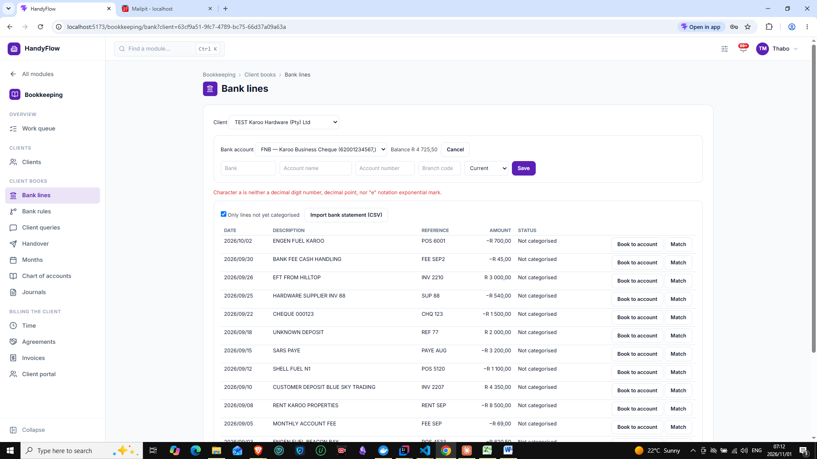
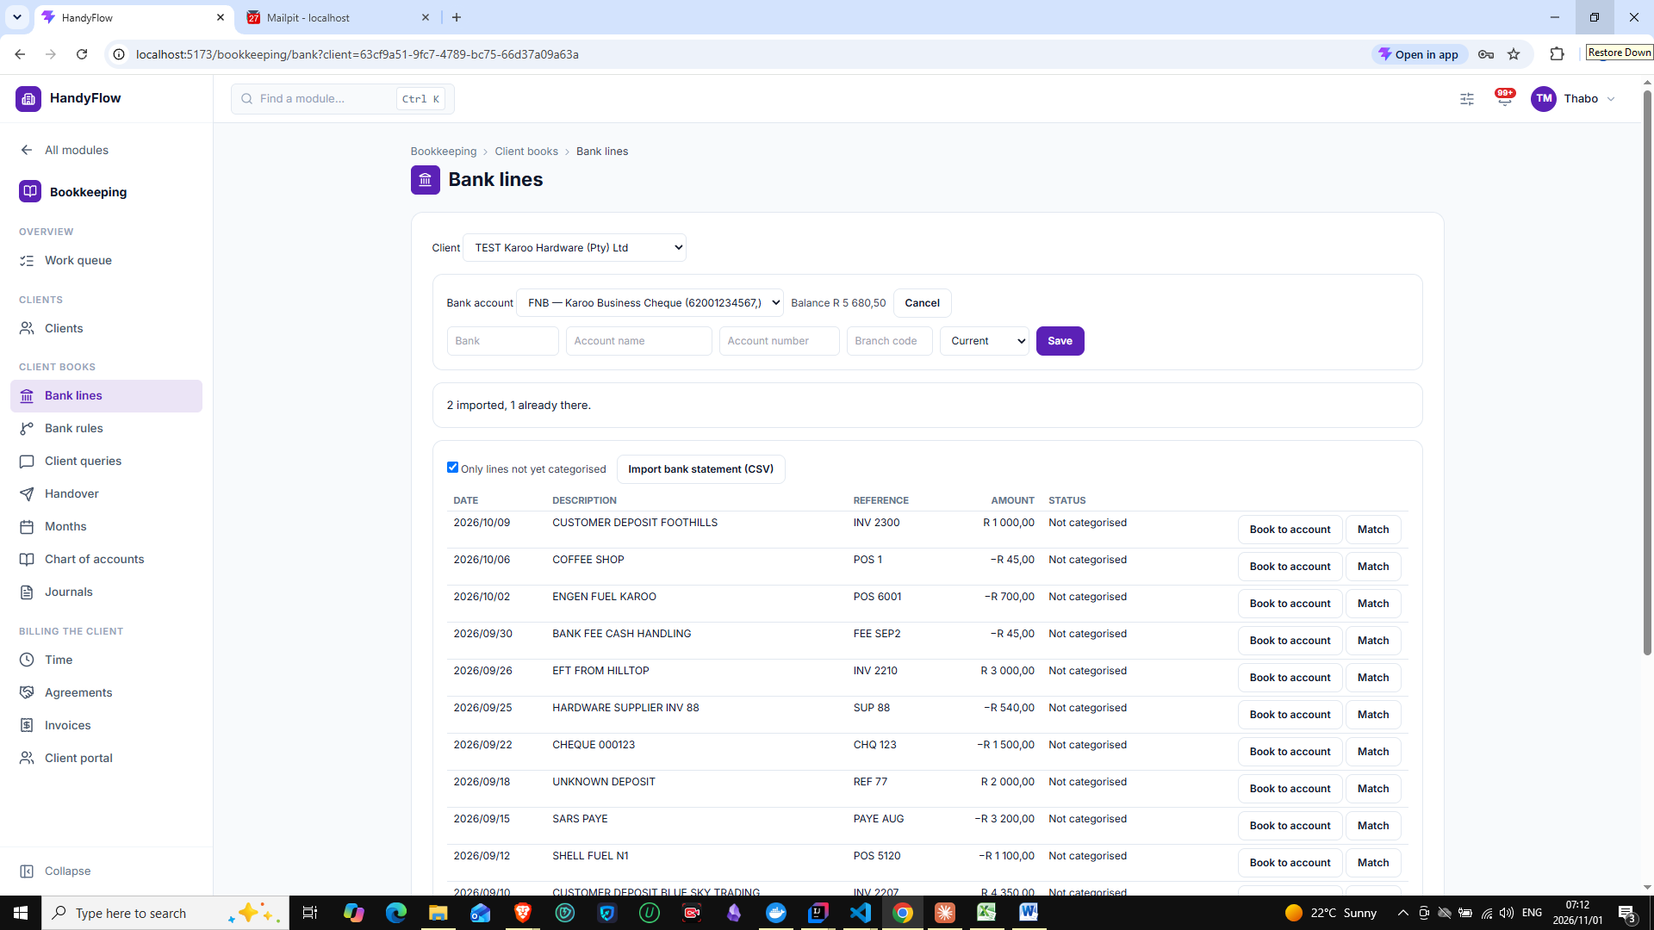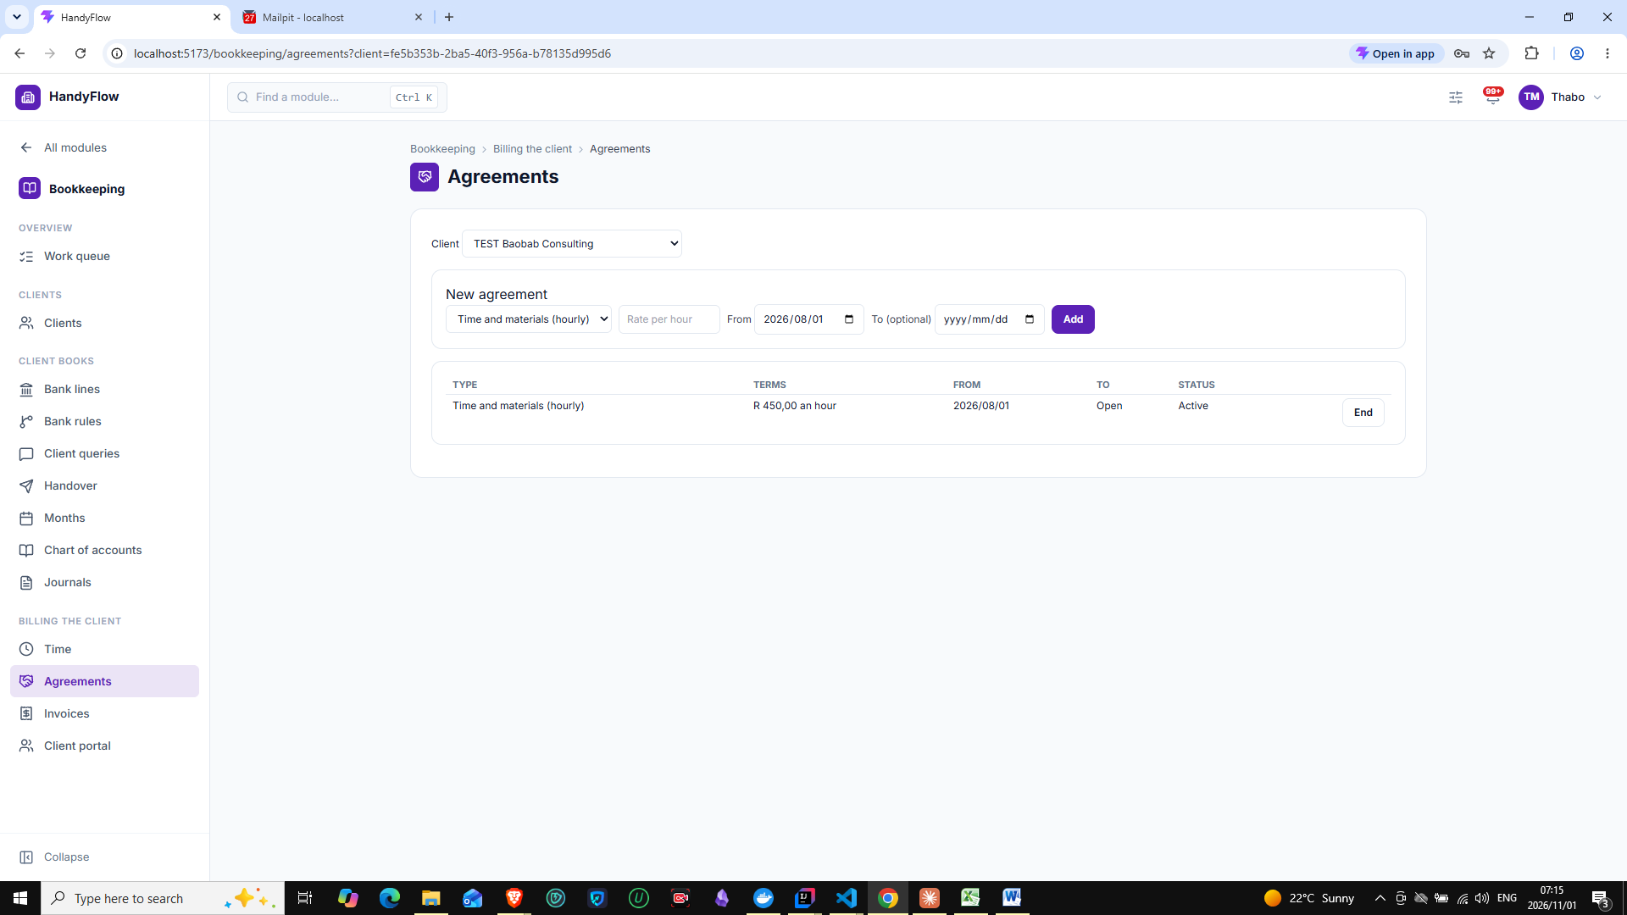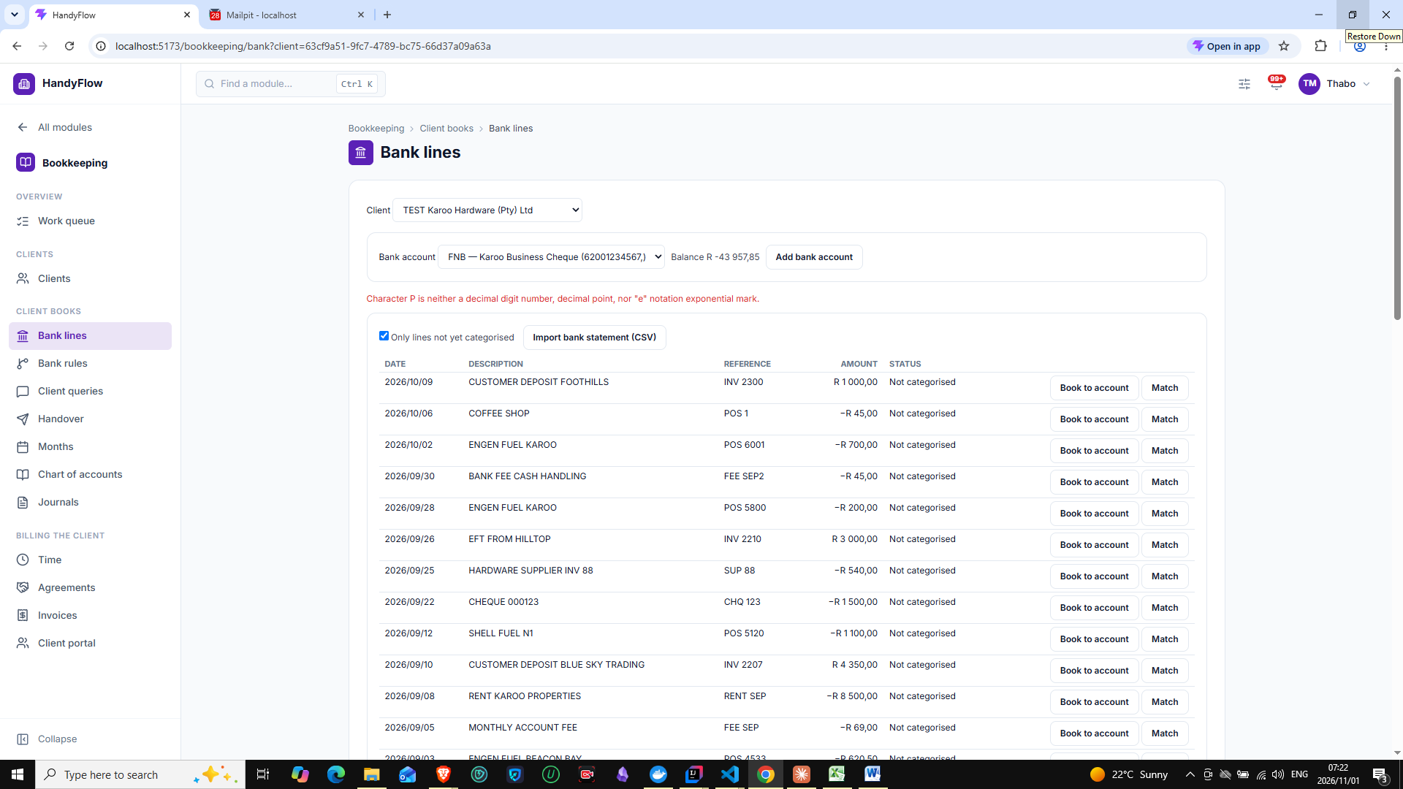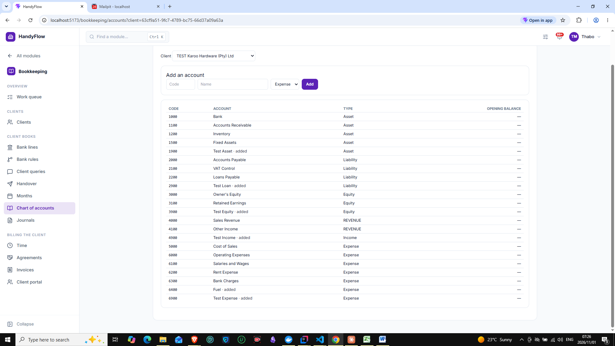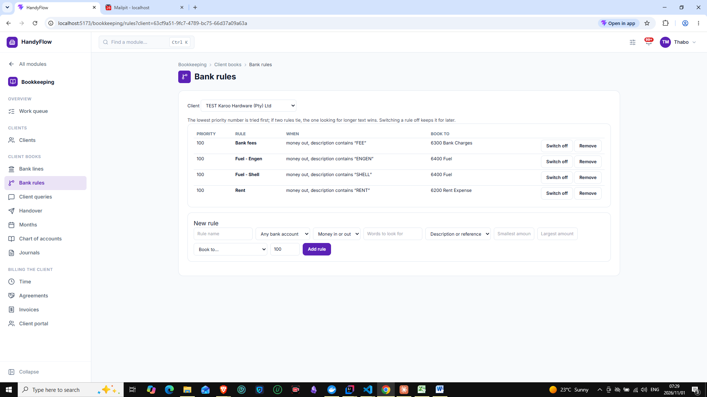
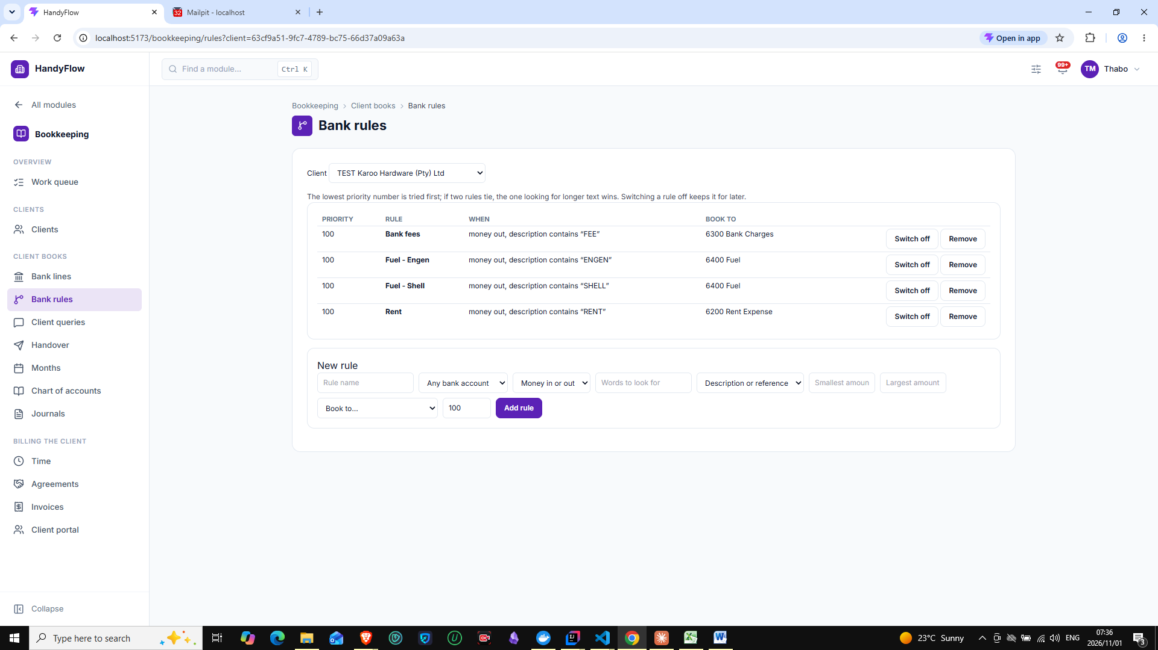
No error shown when clicking add
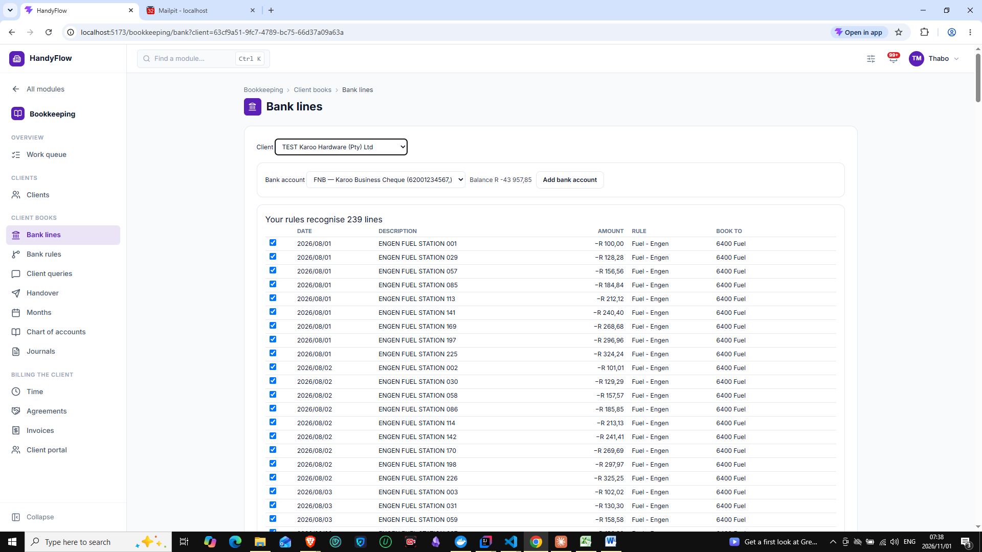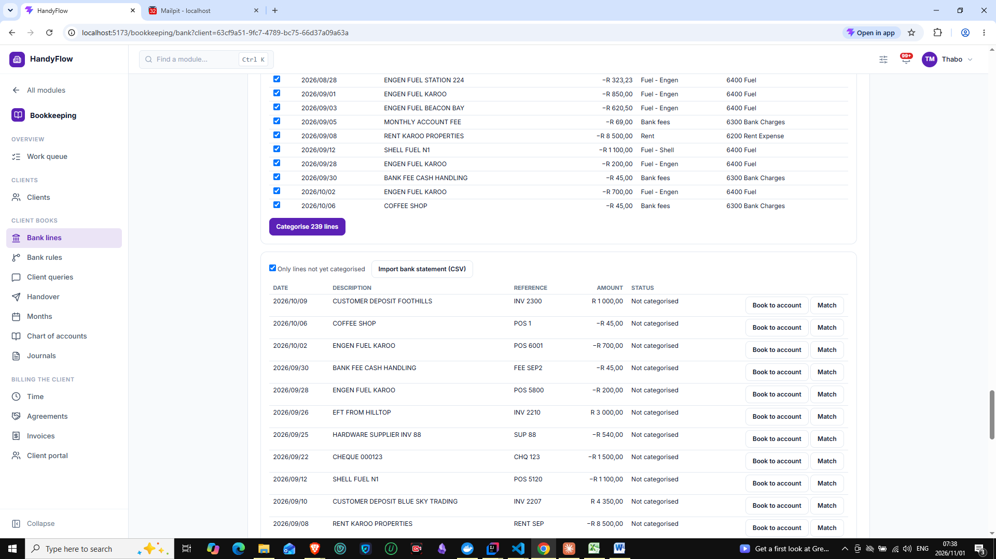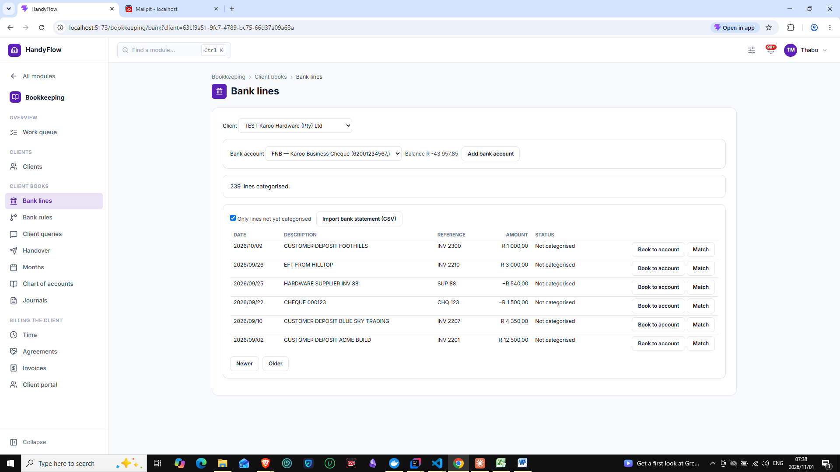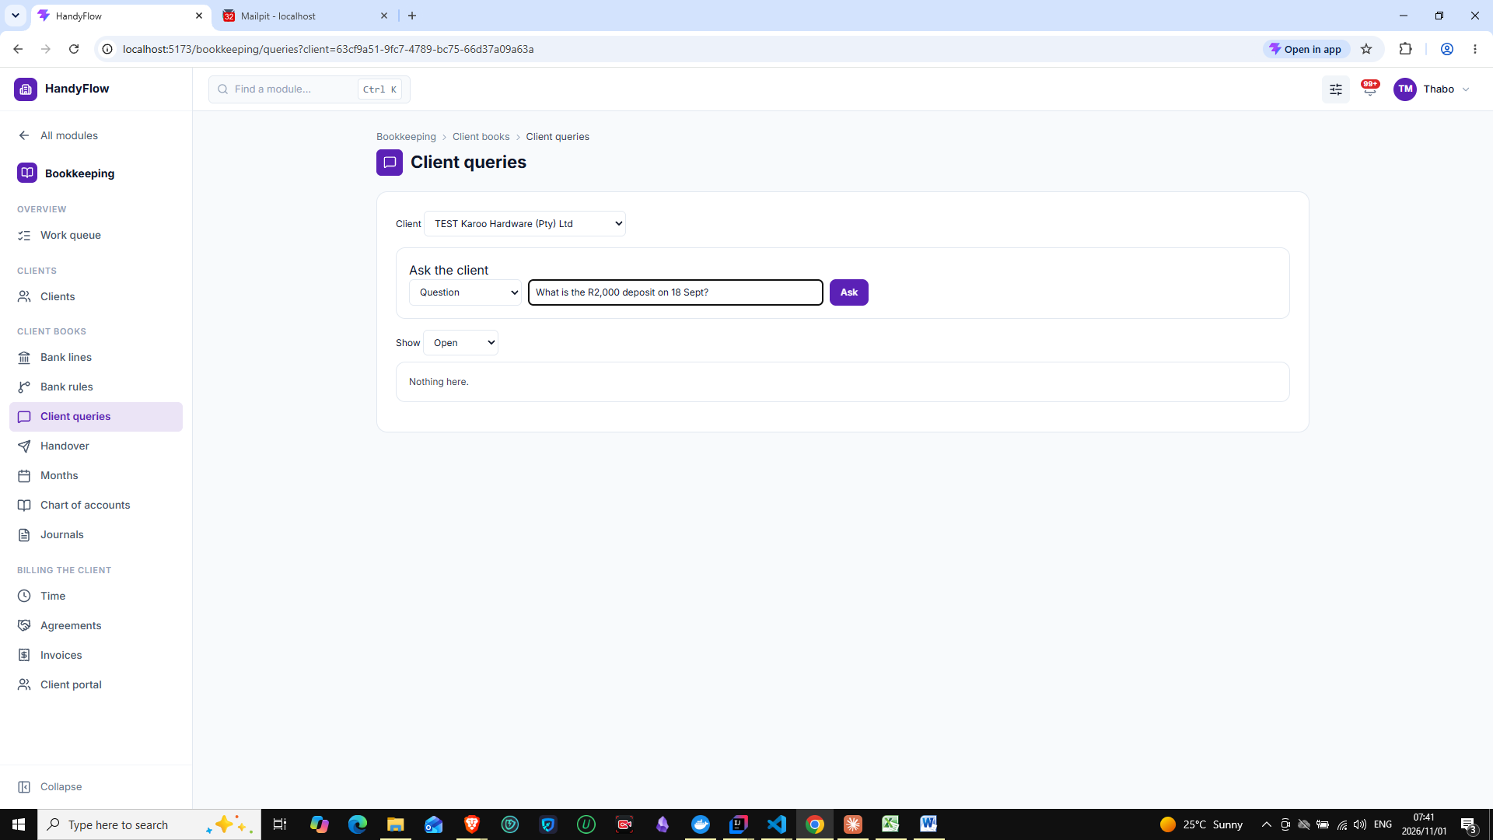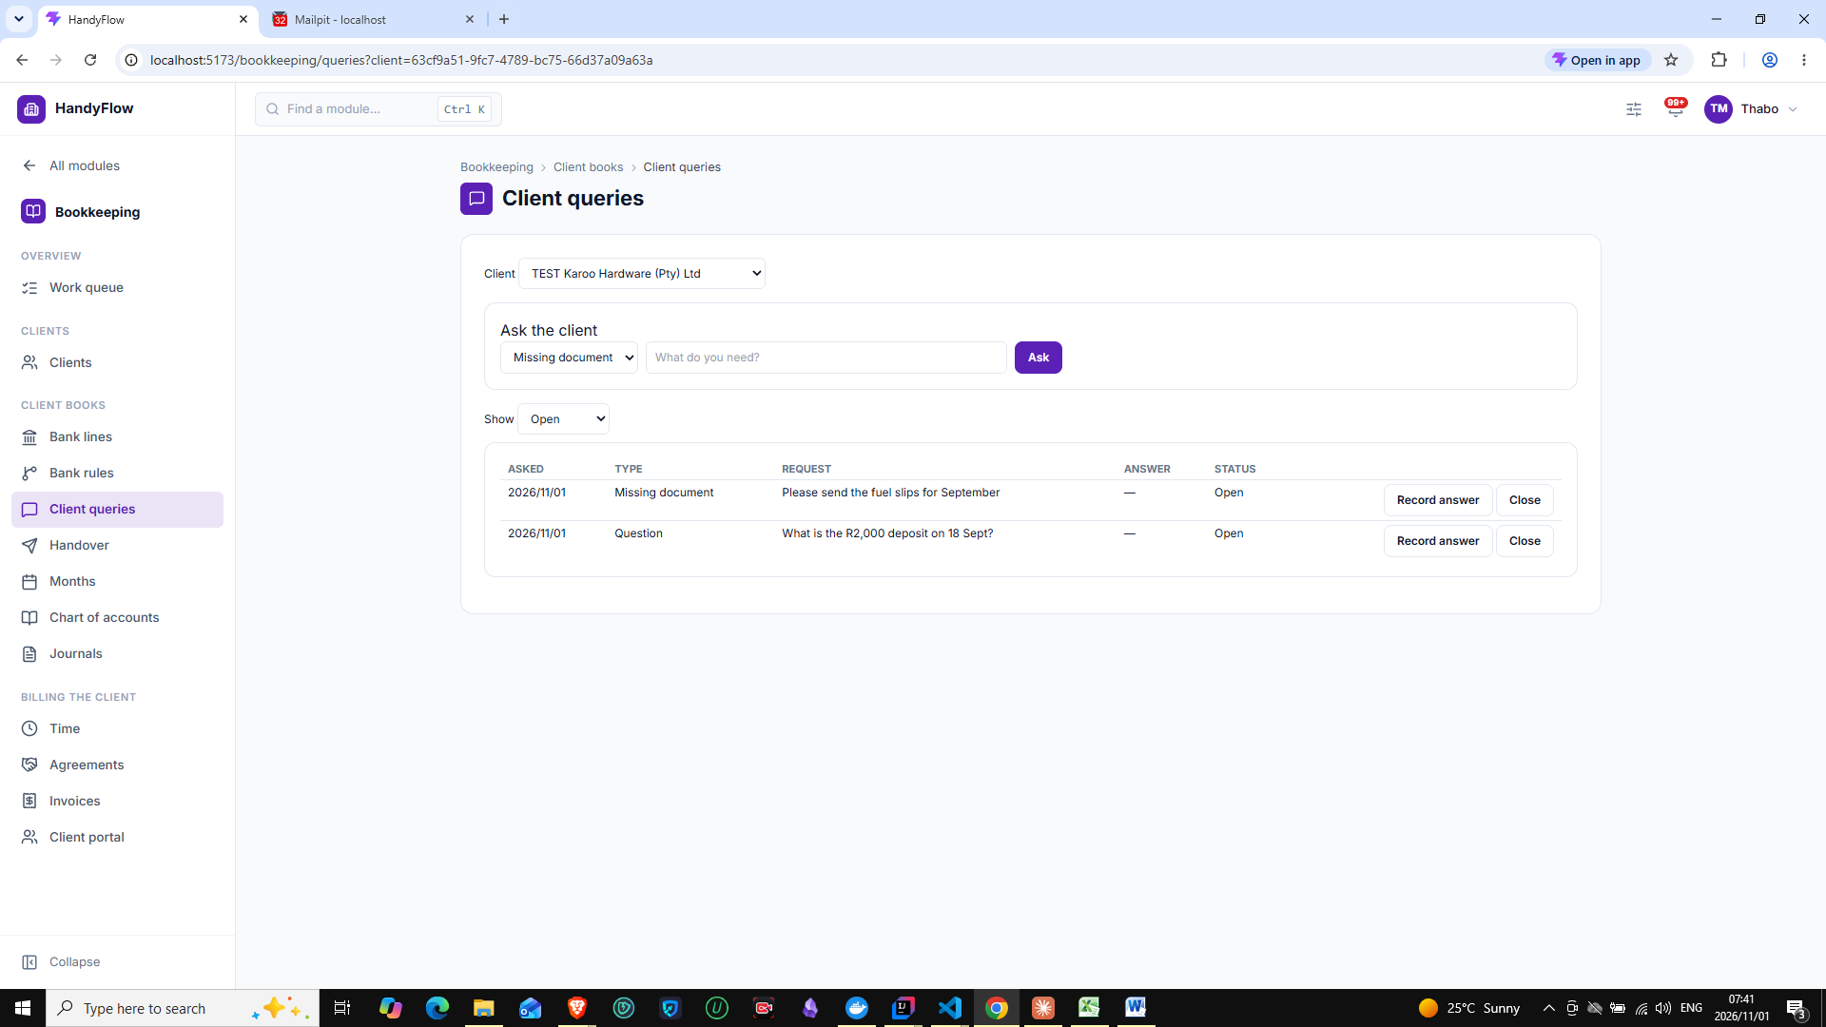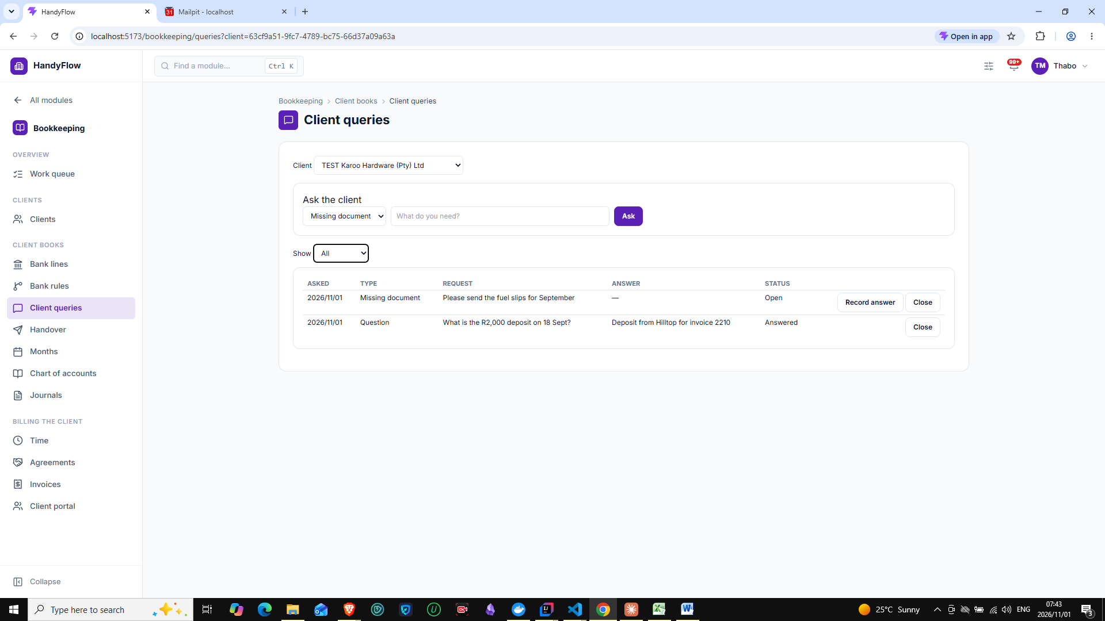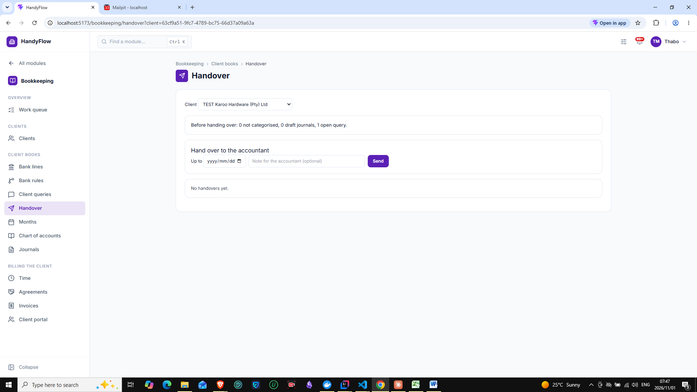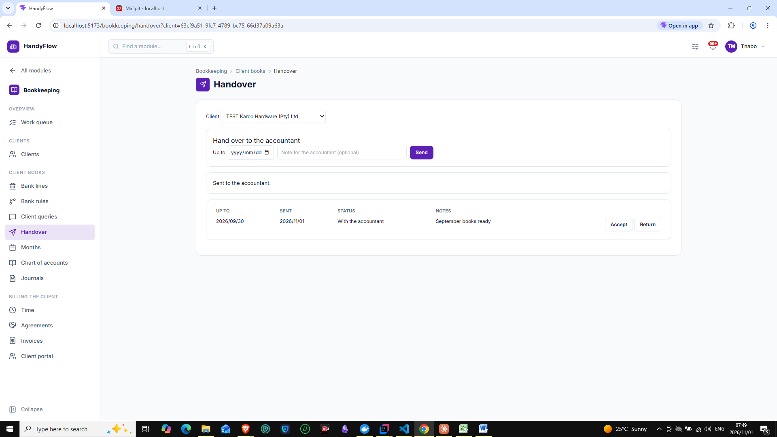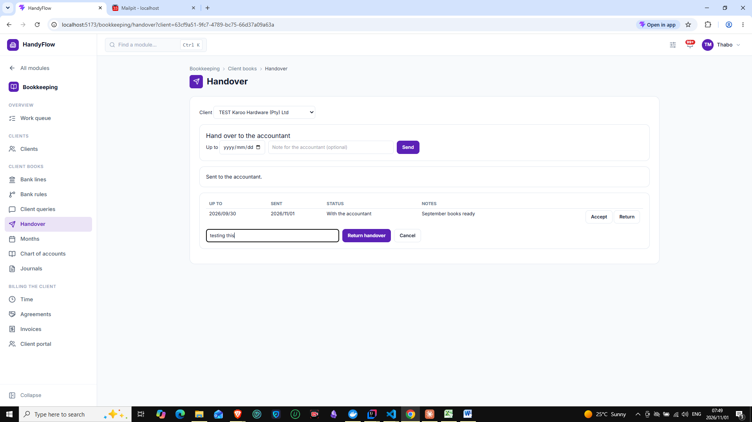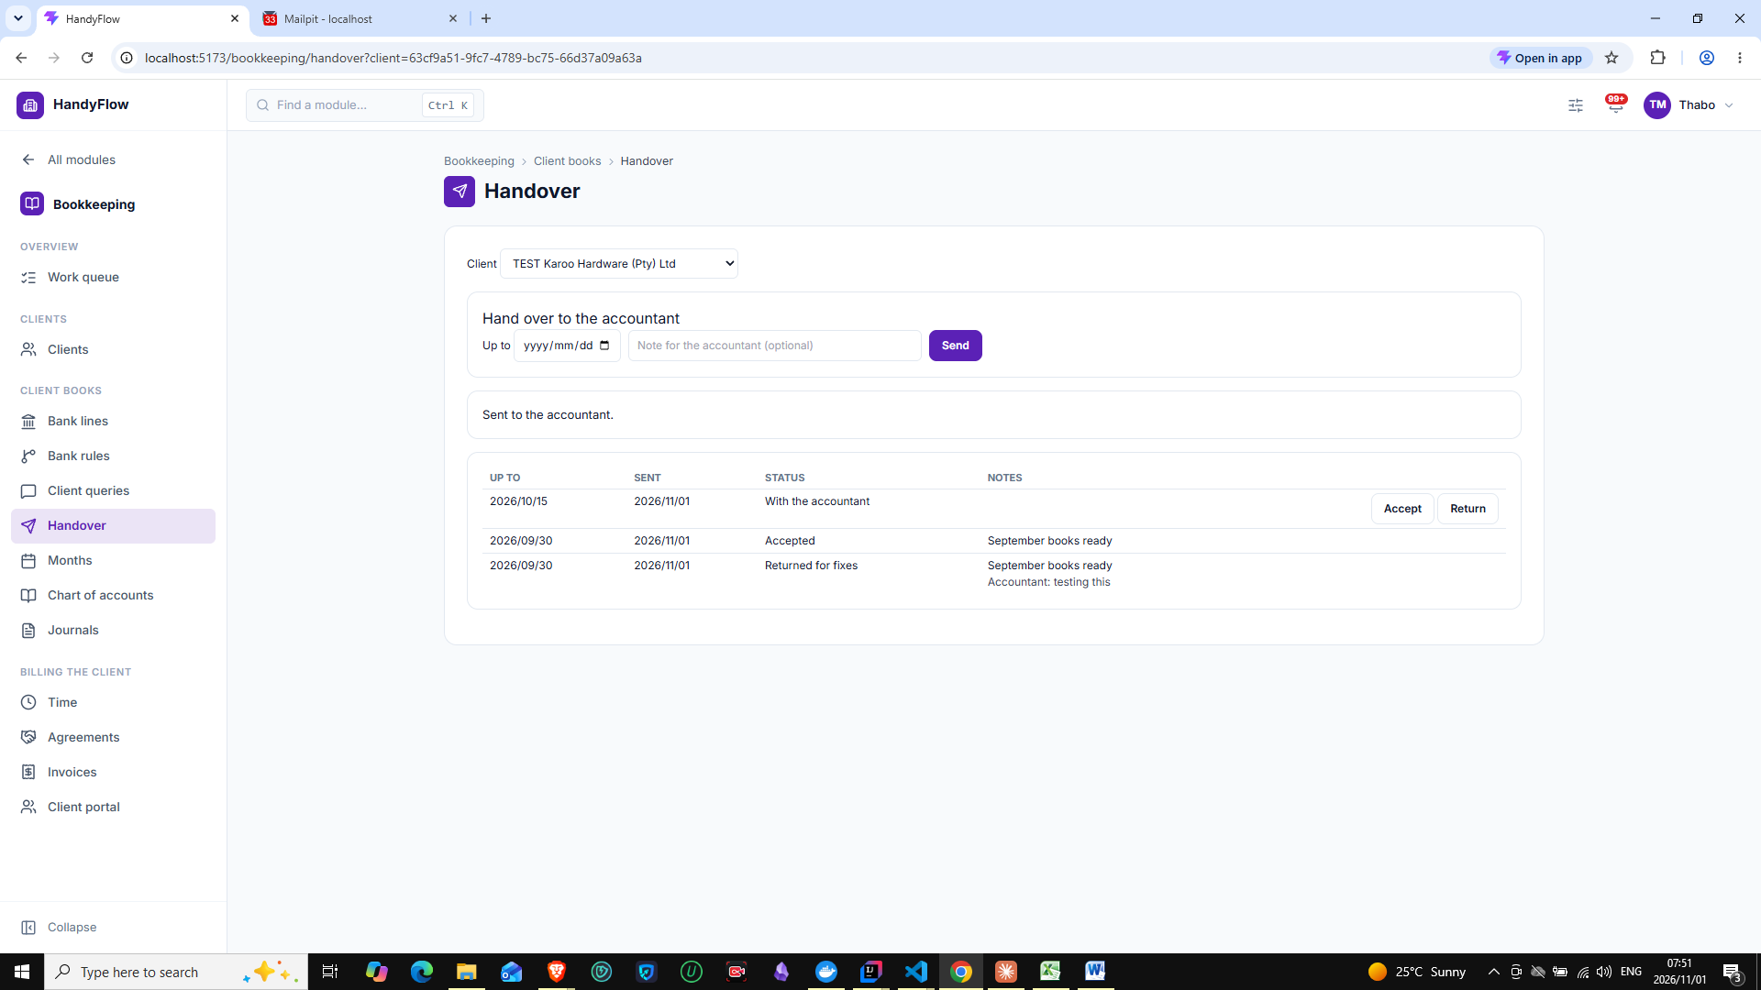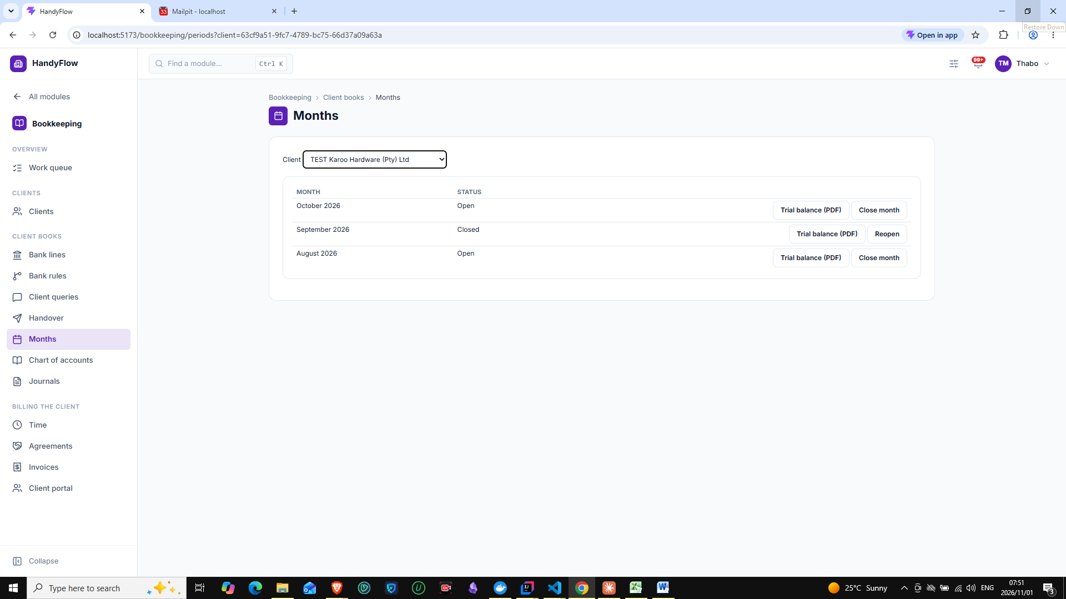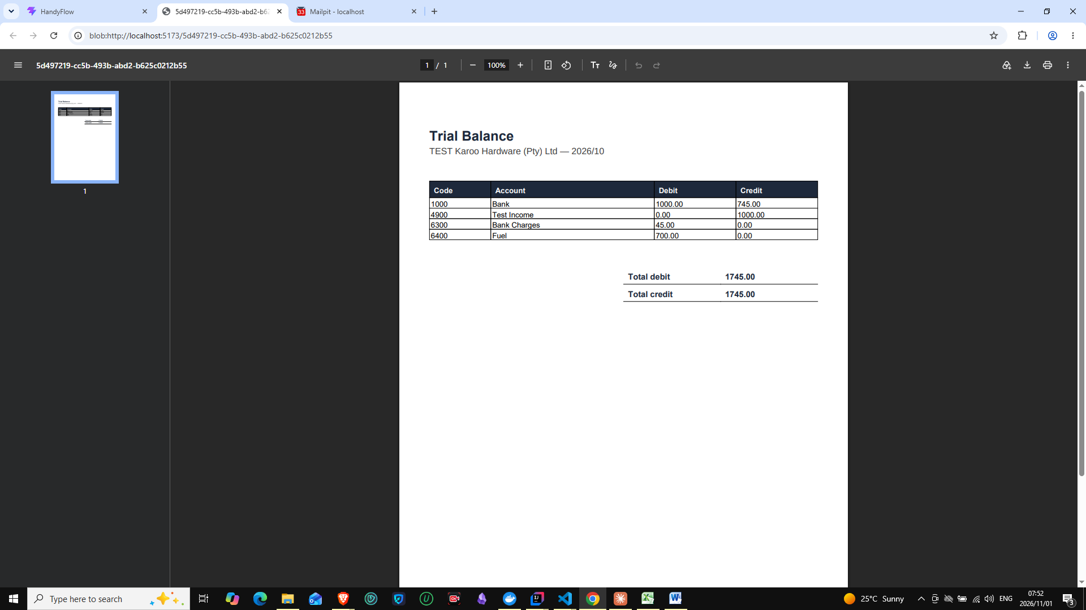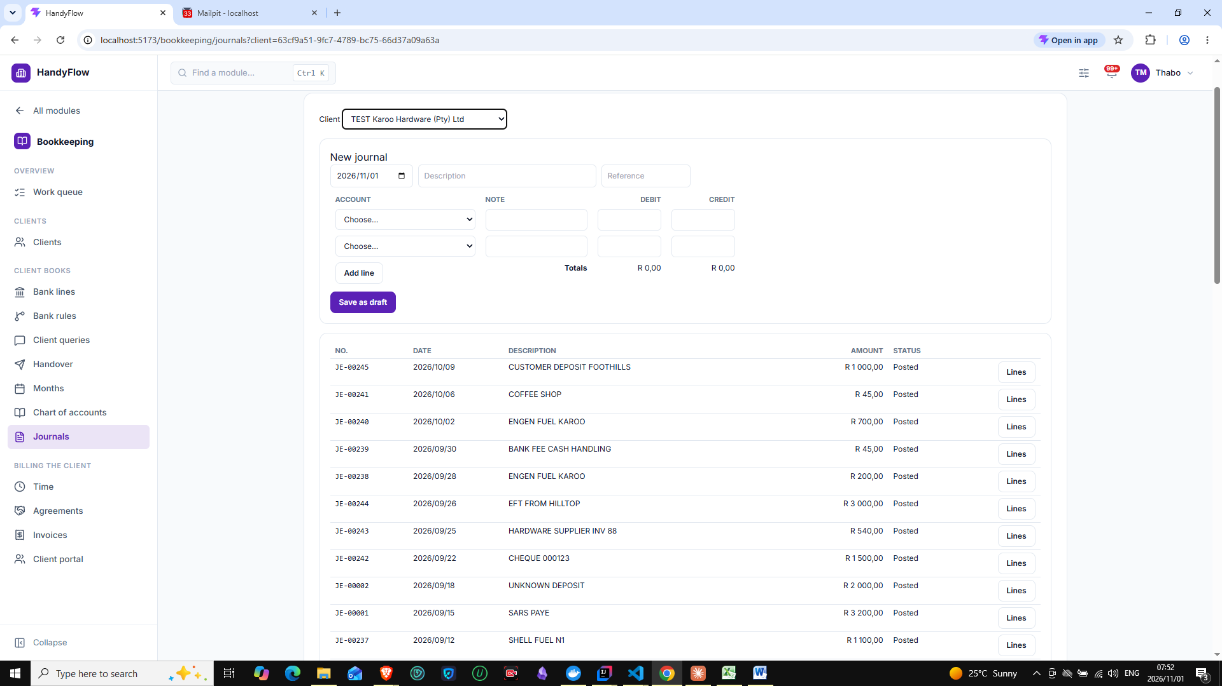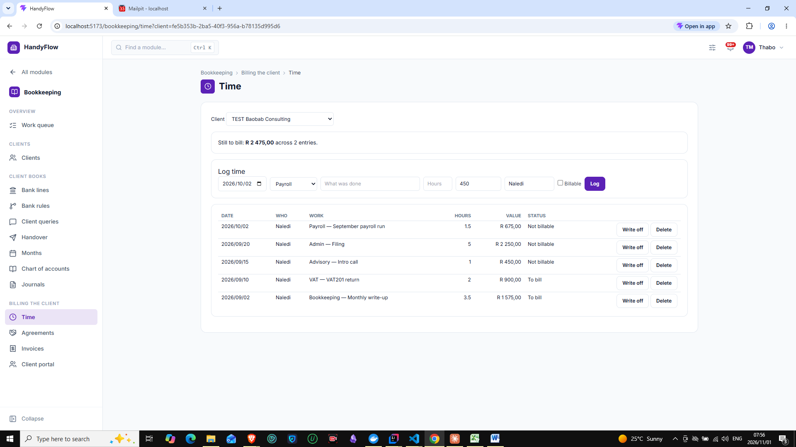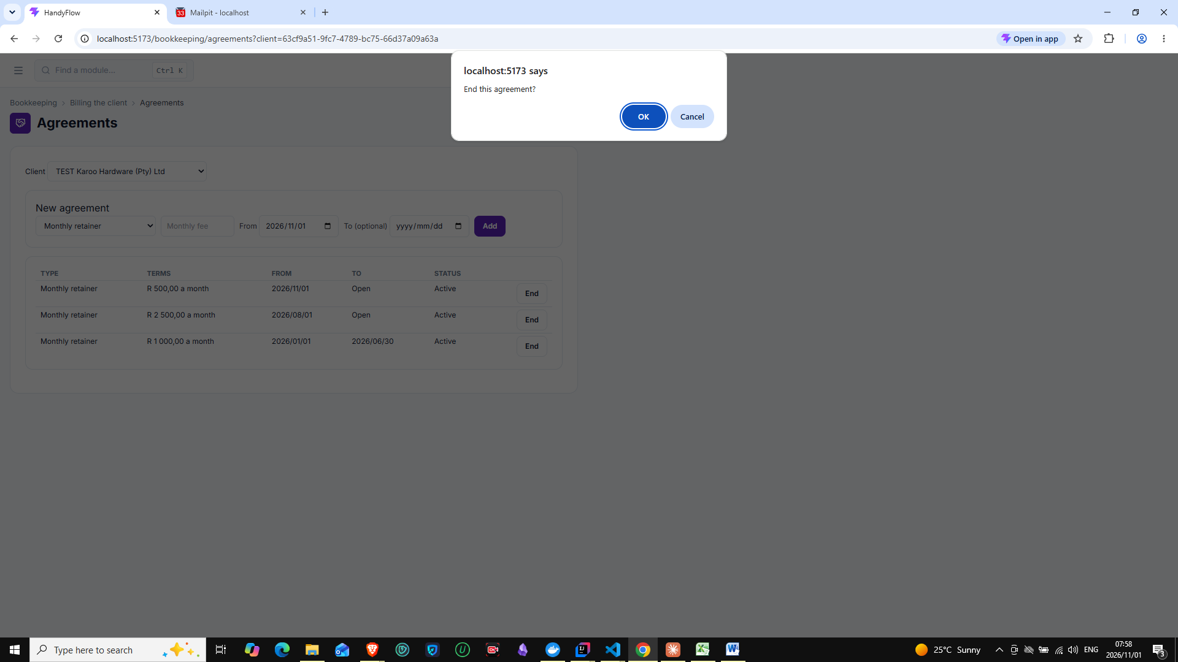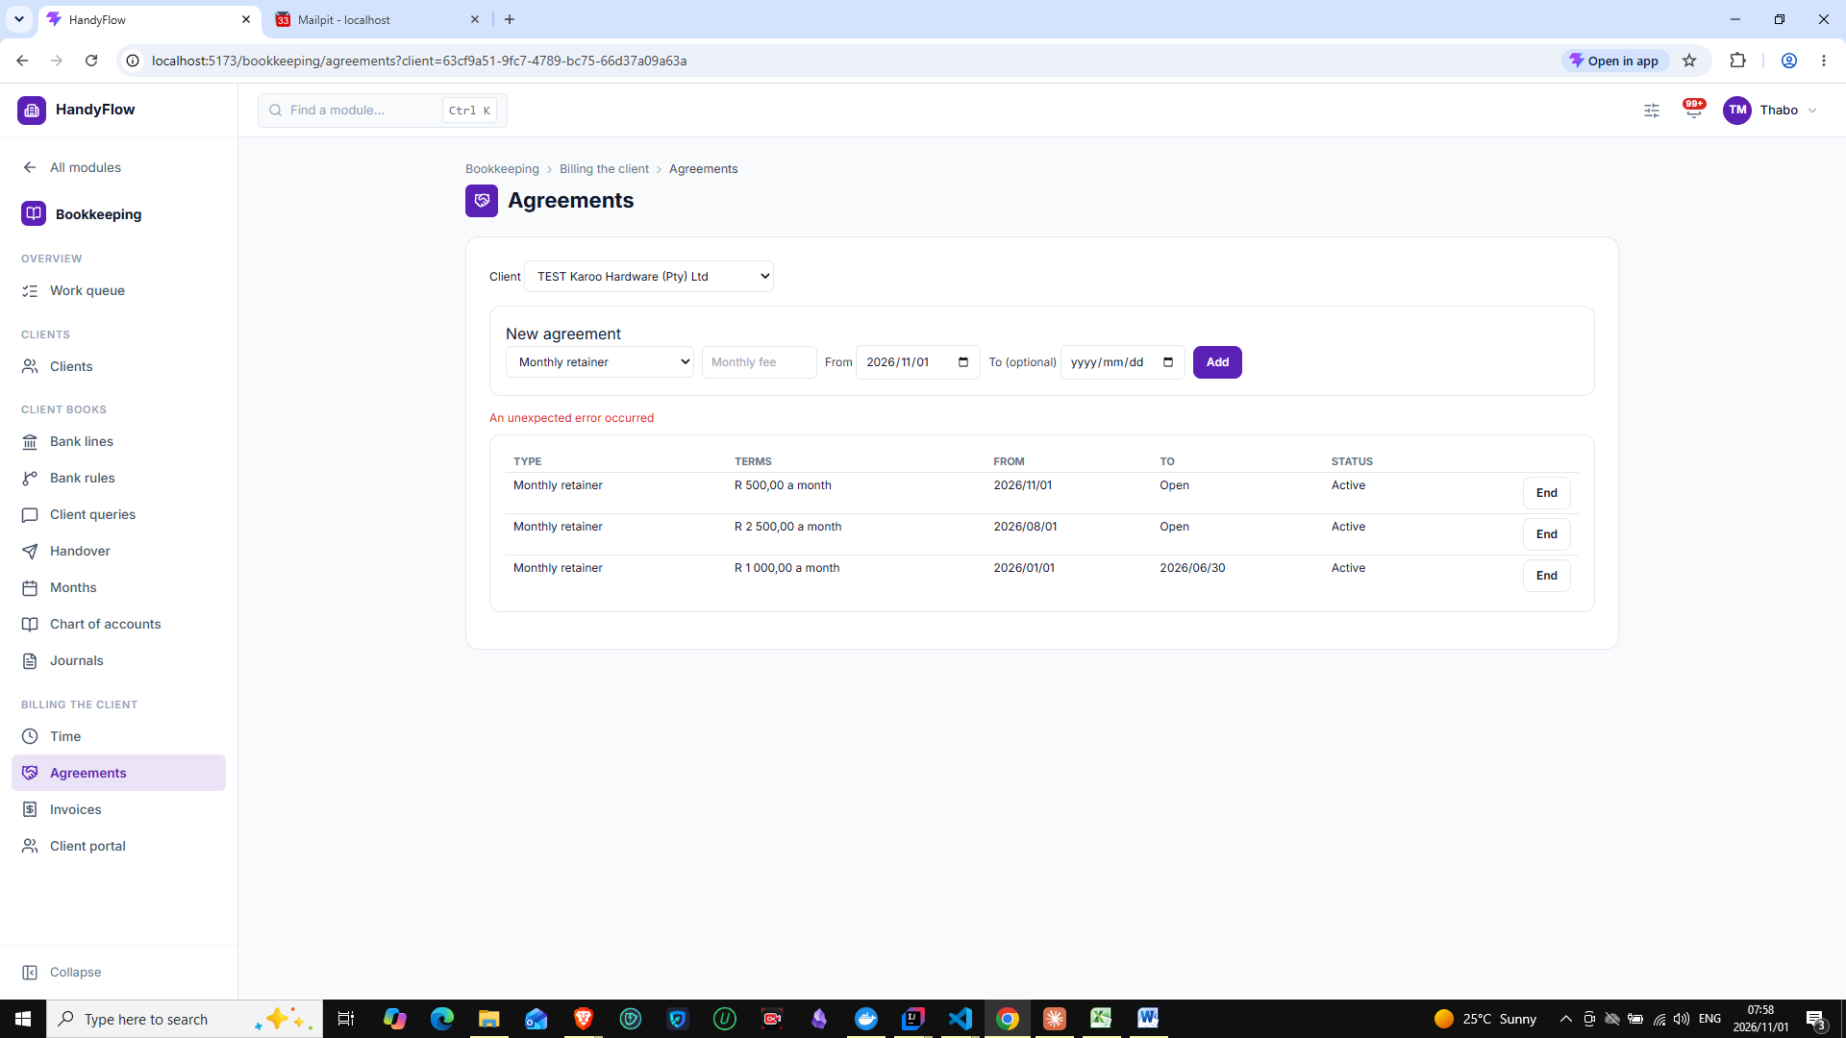
63cf9a51-9fc7-4789-bc75-66d37a09a63a, RETAINER, 500.00, null, 2026-11-01, 2026-11-01, ENDED, 2026-11-01 07:58:19.063148+02, 2026-11-01 07:58:32.854419+02, 1).
2026-11-01 07:58:32 [http-nio-8080-exec-11] ERROR [] [] z.c.h.p.s.GlobalExceptionHandler - Unexpected error
org.springframework.dao.DataIntegrityViolationException: could not execute statement [ERROR: new row for relation "bk_service_agreements" violates check constraint "ck_bk_agreement_end_after_start"
Detail: Failing row contains (193b2690-0565-4cb6-b40f-f7864a5eaf92, 9ecb3dc7-75d4-4e56-b0a2-c95d3c7c584f, 63cf9a51-9fc7-4789-bc75-66d37a09a63a, RETAINER, 500.00, null, 2026-11-01, 2026-11-01, ENDED, 2026-11-01 07:58:19.063148+02, 2026-11-01 07:58:32.854419+02, 1).] [update public.bk_service_agreements set billing_type=?,client_id=?,end_date=?,hourly_rate=?,monthly_fee=?,start_date=?,status=?,tenant_id=?,updated_at=?,version=? where id=? and version=?]; SQL [update public.bk_service_agreements set billing_type=?,client_id=?,end_date=?,hourly_rate=?,monthly_fee=?,start_date=?,status=?,tenant_id=?,updated_at=?,version=? where id=? and version=?]; constraint [ck_bk_agreement_end_after_start]
at org.springframework.orm.jpa.vendor.HibernateJpaDialect.convertHibernateAccessException(HibernateJpaDialect.java:294)
at org.springframework.orm.jpa.vendor.HibernateJpaDialect.convertHibernateAccessException(HibernateJpaDialect.java:256)
at org.springframework.orm.jpa.vendor.HibernateJpaDialect.translateExceptionIfPossible(HibernateJpaDialect.java:241)
at org.springframework.orm.jpa.JpaTransactionManager.doCommit(JpaTransactionManager.java:566)
at org.springframework.transaction.support.AbstractPlatformTransactionManager.processCommit(AbstractPlatformTransactionManager.java:795)
at org.springframework.transaction.support.AbstractPlatformTransactionManager.commit(AbstractPlatformTransactionManager.java:758)
at org.springframework.transaction.interceptor.TransactionAspectSupport.commitTransactionAfterReturning(TransactionAspectSupport.java:698)
at org.springframework.transaction.interceptor.TransactionAspectSupport.invokeWithinTransaction(TransactionAspectSupport.java:416)
at org.springframework.transaction.interceptor.TransactionInterceptor.invoke(TransactionInterceptor.java:119)
at org.springframework.aop.framework.ReflectiveMethodInvocation.proceed(ReflectiveMethodInvocation.java:184)
at org.springframework.aop.framework.CglibAopProxy$DynamicAdvisedInterceptor.intercept(CglibAopProxy.java:728)
at za.co.handyflow.platform.bookkeeping.application.internal.BkServiceAgreementService$$SpringCGLIB$$0.end(<generated>)
at za.co.handyflow.platform.bookkeeping.api.BkServiceAgreementController.end(BkServiceAgreementController.java:70)
at java.base/jdk.internal.reflect.DirectMethodHandleAccessor.invoke(DirectMethodHandleAccessor.java:103)
at java.base/java.lang.reflect.Method.invoke(Method.java:580)
at org.springframework.aop.support.AopUtils.invokeJoinpointUsingReflection(AopUtils.java:359)
at org.springframework.aop.framework.ReflectiveMethodInvocation.invokeJoinpoint(ReflectiveMethodInvocation.java:196)
at org.springframework.aop.framework.ReflectiveMethodInvocation.proceed(ReflectiveMethodInvocation.java:163)
at org.springframework.security.authorization.method.AuthorizationManagerBeforeMethodInterceptor.proceed(AuthorizationManagerBeforeMethodInterceptor.java:268)
at org.springframework.security.authorization.method.AuthorizationManagerBeforeMethodInterceptor.attemptAuthorization(AuthorizationManagerBeforeMethodInterceptor.java:263)
at org.springframework.security.authorization.method.AuthorizationManagerBeforeMethodInterceptor.invoke(AuthorizationManagerBeforeMethodInterceptor.java:196)
at org.springframework.security.config.annotation.method.configuration.DeferringMethodInterceptor.invoke(DeferringMethodInterceptor.java:44)
at org.springframework.aop.framework.ReflectiveMethodInvocation.proceed(ReflectiveMethodInvocation.java:184)
at org.springframework.aop.framework.CglibAopProxy$DynamicAdvisedInterceptor.intercept(CglibAopProxy.java:728)
at za.co.handyflow.platform.bookkeeping.api.BkServiceAgreementController$$SpringCGLIB$$0.end(<generated>)
at java.base/jdk.internal.reflect.DirectMethodHandleAccessor.invoke(DirectMethodHandleAccessor.java:103)
at java.base/java.lang.reflect.Method.invoke(Method.java:580)
at org.springframework.web.method.support.InvocableHandlerMethod.doInvoke(InvocableHandlerMethod.java:258)
at org.springframework.web.method.support.InvocableHandlerMethod.invokeForRequest(InvocableHandlerMethod.java:191)
at org.springframework.web.servlet.mvc.method.annotation.ServletInvocableHandlerMethod.invokeAndHandle(ServletInvocableHandlerMethod.java:118)
at org.springframework.web.servlet.mvc.method.annotation.RequestMappingHandlerAdapter.invokeHandlerMethod(RequestMappingHandlerAdapter.java:986)
at org.springframework.web.servlet.mvc.method.annotation.RequestMappingHandlerAdapter.handleInternal(RequestMappingHandlerAdapter.java:891)
at org.springframework.web.servlet.mvc.method.AbstractHandlerMethodAdapter.handle(AbstractHandlerMethodAdapter.java:87)
at org.springframework.web.servlet.DispatcherServlet.doDispatch(DispatcherServlet.java:1089)
at org.springframework.web.servlet.DispatcherServlet.doService(DispatcherServlet.java:979)
at org.springframework.web.servlet.FrameworkServlet.processRequest(FrameworkServlet.java:1014)
at org.springframework.web.servlet.FrameworkServlet.doPost(FrameworkServlet.java:914)
at jakarta.servlet.http.HttpServlet.service(HttpServlet.java:590)
at org.springframework.web.servlet.FrameworkServlet.service(FrameworkServlet.java:885)
at jakarta.servlet.http.HttpServlet.service(HttpServlet.java:658)
at org.apache.catalina.core.ApplicationFilterChain.internalDoFilter(ApplicationFilterChain.java:195)
at org.apache.catalina.core.ApplicationFilterChain.doFilter(ApplicationFilterChain.java:140)
at org.apache.tomcat.websocket.server.WsFilter.doFilter(WsFilter.java:51)
at org.apache.catalina.core.ApplicationFilterChain.internalDoFilter(ApplicationFilterChain.java:164)
at org.apache.catalina.core.ApplicationFilterChain.doFilter(ApplicationFilterChain.java:140)
at org.springframework.web.filter.OncePerRequestFilter.doFilter(OncePerRequestFilter.java:101)
at org.apache.catalina.core.ApplicationFilterChain.internalDoFilter(ApplicationFilterChain.java:164)
at org.apache.catalina.core.ApplicationFilterChain.doFilter(ApplicationFilterChain.java:140)
at org.springframework.web.filter.OncePerRequestFilter.doFilter(OncePerRequestFilter.java:110)
at org.apache.catalina.core.ApplicationFilterChain.internalDoFilter(ApplicationFilterChain.java:164)
at org.apache.catalina.core.ApplicationFilterChain.doFilter(ApplicationFilterChain.java:140)
at org.springframework.web.filter.OncePerRequestFilter.doFilter(OncePerRequestFilter.java:101)
at org.apache.catalina.core.ApplicationFilterChain.internalDoFilter(ApplicationFilterChain.java:164)
at org.apache.catalina.core.ApplicationFilterChain.doFilter(ApplicationFilterChain.java:140)
at org.springframework.web.filter.OncePerRequestFilter.doFilter(OncePerRequestFilter.java:101)
at org.apache.catalina.core.ApplicationFilterChain.internalDoFilter(ApplicationFilterChain.java:164)
at org.apache.catalina.core.ApplicationFilterChain.doFilter(ApplicationFilterChain.java:140)
at org.springframework.web.filter.OncePerRequestFilter.doFilter(OncePerRequestFilter.java:110)
at org.apache.catalina.core.ApplicationFilterChain.internalDoFilter(ApplicationFilterChain.java:164)
at org.apache.catalina.core.ApplicationFilterChain.doFilter(ApplicationFilterChain.java:140)
at org.springframework.web.filter.OncePerRequestFilter.doFilter(OncePerRequestFilter.java:110)
at org.apache.catalina.core.ApplicationFilterChain.internalDoFilter(ApplicationFilterChain.java:164)
at org.apache.catalina.core.ApplicationFilterChain.doFilter(ApplicationFilterChain.java:140)
at org.springframework.web.filter.OncePerRequestFilter.doFilter(OncePerRequestFilter.java:101)
at org.apache.catalina.core.ApplicationFilterChain.internalDoFilter(ApplicationFilterChain.java:164)
at org.apache.catalina.core.ApplicationFilterChain.doFilter(ApplicationFilterChain.java:140)
at org.springframework.web.filter.CompositeFilter$VirtualFilterChain.doFilter(CompositeFilter.java:108)
at org.springframework.security.web.FilterChainProxy.lambda$doFilterInternal$3(FilterChainProxy.java:231)
at org.springframework.security.web.ObservationFilterChainDecorator$FilterObservation$SimpleFilterObservation.lambda$wrap$1(ObservationFilterChainDecorator.java:479)
at org.springframework.security.web.ObservationFilterChainDecorator$AroundFilterObservation$SimpleAroundFilterObservation.lambda$wrap$1(ObservationFilterChainDecorator.java:340)
at org.springframework.security.web.ObservationFilterChainDecorator.lambda$wrapSecured$0(ObservationFilterChainDecorator.java:82)
at org.springframework.security.web.ObservationFilterChainDecorator$VirtualFilterChain.doFilter(ObservationFilterChainDecorator.java:128)
at org.springframework.security.web.access.intercept.AuthorizationFilter.doFilter(AuthorizationFilter.java:101)
at org.springframework.security.web.ObservationFilterChainDecorator$ObservationFilter.wrapFilter(ObservationFilterChainDecorator.java:240)
at org.springframework.security.web.ObservationFilterChainDecorator$ObservationFilter.doFilter(ObservationFilterChainDecorator.java:227)
at org.springframework.security.web.ObservationFilterChainDecorator$VirtualFilterChain.doFilter(ObservationFilterChainDecorator.java:137)
at org.springframework.security.web.access.ExceptionTranslationFilter.doFilter(ExceptionTranslationFilter.java:126)
at org.springframework.security.web.access.ExceptionTranslationFilter.doFilter(ExceptionTranslationFilter.java:120)
at org.springframework.security.web.ObservationFilterChainDecorator$ObservationFilter.wrapFilter(ObservationFilterChainDecorator.java:240)
at org.springframework.security.web.ObservationFilterChainDecorator$ObservationFilter.doFilter(ObservationFilterChainDecorator.java:227)
at org.springframework.security.web.ObservationFilterChainDecorator$VirtualFilterChain.doFilter(ObservationFilterChainDecorator.java:137)
at org.springframework.security.web.session.SessionManagementFilter.doFilter(SessionManagementFilter.java:131)
at org.springframework.security.web.session.SessionManagementFilter.doFilter(SessionManagementFilter.java:85)
at org.springframework.security.web.ObservationFilterChainDecorator$ObservationFilter.wrapFilter(ObservationFilterChainDecorator.java:240)
at org.springframework.security.web.ObservationFilterChainDecorator$ObservationFilter.doFilter(ObservationFilterChainDecorator.java:227)
at org.springframework.security.web.ObservationFilterChainDecorator$VirtualFilterChain.doFilter(ObservationFilterChainDecorator.java:137)
at org.springframework.security.web.authentication.AnonymousAuthenticationFilter.doFilter(AnonymousAuthenticationFilter.java:100)
at org.springframework.security.web.ObservationFilterChainDecorator$ObservationFilter.wrapFilter(ObservationFilterChainDecorator.java:240)
at org.springframework.security.web.ObservationFilterChainDecorator$ObservationFilter.doFilter(ObservationFilterChainDecorator.java:227)
at org.springframework.security.web.ObservationFilterChainDecorator$VirtualFilterChain.doFilter(ObservationFilterChainDecorator.java:137)
at org.springframework.security.web.servletapi.SecurityContextHolderAwareRequestFilter.doFilter(SecurityContextHolderAwareRequestFilter.java:179)
at org.springframework.security.web.ObservationFilterChainDecorator$ObservationFilter.wrapFilter(ObservationFilterChainDecorator.java:240)
at org.springframework.security.web.ObservationFilterChainDecorator$ObservationFilter.doFilter(ObservationFilterChainDecorator.java:227)
at org.springframework.security.web.ObservationFilterChainDecorator$VirtualFilterChain.doFilter(ObservationFilterChainDecorator.java:137)
at org.springframework.security.web.savedrequest.RequestCacheAwareFilter.doFilter(RequestCacheAwareFilter.java:63)
at org.springframework.security.web.ObservationFilterChainDecorator$ObservationFilter.wrapFilter(ObservationFilterChainDecorator.java:240)
at org.springframework.security.web.ObservationFilterChainDecorator$ObservationFilter.doFilter(ObservationFilterChainDecorator.java:227)
at org.springframework.security.web.ObservationFilterChainDecorator$VirtualFilterChain.doFilter(ObservationFilterChainDecorator.java:137)
at za.co.handyflow.platform.config.IdempotencyKeyFilter.doFilterInternal(IdempotencyKeyFilter.java:66)
at org.springframework.web.filter.OncePerRequestFilter.doFilter(OncePerRequestFilter.java:116)
at org.springframework.security.web.ObservationFilterChainDecorator$ObservationFilter.wrapFilter(ObservationFilterChainDecorator.java:240)
at org.springframework.security.web.ObservationFilterChainDecorator$ObservationFilter.doFilter(ObservationFilterChainDecorator.java:227)
at org.springframework.security.web.ObservationFilterChainDecorator$VirtualFilterChain.doFilter(ObservationFilterChainDecorator.java:137)
at org.springframework.web.filter.OncePerRequestFilter.doFilter(OncePerRequestFilter.java:101)
at org.springframework.security.web.ObservationFilterChainDecorator$ObservationFilter.wrapFilter(ObservationFilterChainDecorator.java:240)
at org.springframework.security.web.ObservationFilterChainDecorator$ObservationFilter.doFilter(ObservationFilterChainDecorator.java:227)
at org.springframework.security.web.ObservationFilterChainDecorator$VirtualFilterChain.doFilter(ObservationFilterChainDecorator.java:137)
at org.springframework.web.filter.OncePerRequestFilter.doFilter(OncePerRequestFilter.java:101)
at org.springframework.security.web.ObservationFilterChainDecorator$ObservationFilter.wrapFilter(ObservationFilterChainDecorator.java:240)
at org.springframework.security.web.ObservationFilterChainDecorator$ObservationFilter.doFilter(ObservationFilterChainDecorator.java:227)
at org.springframework.security.web.ObservationFilterChainDecorator$VirtualFilterChain.doFilter(ObservationFilterChainDecorator.java:137)
at za.co.handyflow.platform.shared.JwtAuthFilter.doFilterInternal(JwtAuthFilter.java:76)
at org.springframework.web.filter.OncePerRequestFilter.doFilter(OncePerRequestFilter.java:116)
at org.springframework.security.web.ObservationFilterChainDecorator$ObservationFilter.wrapFilter(ObservationFilterChainDecorator.java:240)
at org.springframework.security.web.ObservationFilterChainDecorator$ObservationFilter.doFilter(ObservationFilterChainDecorator.java:227)
at org.springframework.security.web.ObservationFilterChainDecorator$VirtualFilterChain.doFilter(ObservationFilterChainDecorator.java:137)
at org.springframework.web.filter.OncePerRequestFilter.doFilter(OncePerRequestFilter.java:101)
at org.springframework.security.web.ObservationFilterChainDecorator$ObservationFilter.wrapFilter(ObservationFilterChainDecorator.java:240)
at org.springframework.security.web.ObservationFilterChainDecorator$ObservationFilter.doFilter(ObservationFilterChainDecorator.java:227)
at org.springframework.security.web.ObservationFilterChainDecorator$VirtualFilterChain.doFilter(ObservationFilterChainDecorator.java:137)
at org.springframework.web.filter.OncePerRequestFilter.doFilter(OncePerRequestFilter.java:101)
at org.springframework.security.web.ObservationFilterChainDecorator$ObservationFilter.wrapFilter(ObservationFilterChainDecorator.java:240)
at org.springframework.security.web.ObservationFilterChainDecorator$ObservationFilter.doFilter(ObservationFilterChainDecorator.java:227)
at org.springframework.security.web.ObservationFilterChainDecorator$VirtualFilterChain.doFilter(ObservationFilterChainDecorator.java:137)
at za.co.handyflow.platform.config.RateLimitFilter.doFilterInternal(RateLimitFilter.java:177)
at org.springframework.web.filter.OncePerRequestFilter.doFilter(OncePerRequestFilter.java:116)
at org.springframework.security.web.ObservationFilterChainDecorator$ObservationFilter.wrapFilter(ObservationFilterChainDecorator.java:240)
at org.springframework.security.web.ObservationFilterChainDecorator$ObservationFilter.doFilter(ObservationFilterChainDecorator.java:227)
at org.springframework.security.web.ObservationFilterChainDecorator$VirtualFilterChain.doFilter(ObservationFilterChainDecorator.java:137)
at org.springframework.security.web.authentication.logout.LogoutFilter.doFilter(LogoutFilter.java:107)
at org.springframework.security.web.authentication.logout.LogoutFilter.doFilter(LogoutFilter.java:93)
at org.springframework.security.web.ObservationFilterChainDecorator$ObservationFilter.wrapFilter(ObservationFilterChainDecorator.java:240)
at org.springframework.security.web.ObservationFilterChainDecorator$ObservationFilter.doFilter(ObservationFilterChainDecorator.java:227)
at org.springframework.security.web.ObservationFilterChainDecorator$VirtualFilterChain.doFilter(ObservationFilterChainDecorator.java:137)
at org.springframework.web.filter.CorsFilter.doFilterInternal(CorsFilter.java:91)
at org.springframework.web.filter.OncePerRequestFilter.doFilter(OncePerRequestFilter.java:116)
at org.springframework.security.web.ObservationFilterChainDecorator$ObservationFilter.wrapFilter(ObservationFilterChainDecorator.java:240)
at org.springframework.security.web.ObservationFilterChainDecorator$ObservationFilter.doFilter(ObservationFilterChainDecorator.java:227)
at org.springframework.security.web.ObservationFilterChainDecorator$VirtualFilterChain.doFilter(ObservationFilterChainDecorator.java:137)
at org.springframework.security.web.header.HeaderWriterFilter.doHeadersAfter(HeaderWriterFilter.java:90)
at org.springframework.security.web.header.HeaderWriterFilter.doFilterInternal(HeaderWriterFilter.java:75)
at org.springframework.web.filter.OncePerRequestFilter.doFilter(OncePerRequestFilter.java:116)
at org.springframework.security.web.ObservationFilterChainDecorator$ObservationFilter.wrapFilter(ObservationFilterChainDecorator.java:240)
at org.springframework.security.web.ObservationFilterChainDecorator$ObservationFilter.doFilter(ObservationFilterChainDecorator.java:227)
at org.springframework.security.web.ObservationFilterChainDecorator$VirtualFilterChain.doFilter(ObservationFilterChainDecorator.java:137)
at org.springframework.security.web.context.SecurityContextHolderFilter.doFilter(SecurityContextHolderFilter.java:82)
at org.springframework.security.web.context.SecurityContextHolderFilter.doFilter(SecurityContextHolderFilter.java:69)
at org.springframework.security.web.ObservationFilterChainDecorator$ObservationFilter.wrapFilter(ObservationFilterChainDecorator.java:240)
at org.springframework.security.web.ObservationFilterChainDecorator$ObservationFilter.doFilter(ObservationFilterChainDecorator.java:227)
at org.springframework.security.web.ObservationFilterChainDecorator$VirtualFilterChain.doFilter(ObservationFilterChainDecorator.java:137)
at org.springframework.security.web.context.request.async.WebAsyncManagerIntegrationFilter.doFilterInternal(WebAsyncManagerIntegrationFilter.java:62)
at org.springframework.web.filter.OncePerRequestFilter.doFilter(OncePerRequestFilter.java:116)
at org.springframework.security.web.ObservationFilterChainDecorator$ObservationFilter.wrapFilter(ObservationFilterChainDecorator.java:240)
at org.springframework.security.web.ObservationFilterChainDecorator$ObservationFilter.doFilter(ObservationFilterChainDecorator.java:227)
at org.springframework.security.web.ObservationFilterChainDecorator$VirtualFilterChain.doFilter(ObservationFilterChainDecorator.java:137)
at org.springframework.security.web.session.DisableEncodeUrlFilter.doFilterInternal(DisableEncodeUrlFilter.java:42)
at org.springframework.web.filter.OncePerRequestFilter.doFilter(OncePerRequestFilter.java:116)
at org.springframework.security.web.ObservationFilterChainDecorator$ObservationFilter.wrapFilter(ObservationFilterChainDecorator.java:240)
at org.springframework.security.web.ObservationFilterChainDecorator$AroundFilterObservation$SimpleAroundFilterObservation.lambda$wrap$0(ObservationFilterChainDecorator.java:323)
at org.springframework.security.web.ObservationFilterChainDecorator$ObservationFilter.doFilter(ObservationFilterChainDecorator.java:224)
at org.springframework.security.web.ObservationFilterChainDecorator$VirtualFilterChain.doFilter(ObservationFilterChainDecorator.java:137)
at org.springframework.security.web.FilterChainProxy.doFilterInternal(FilterChainProxy.java:233)
at org.springframework.security.web.FilterChainProxy.doFilter(FilterChainProxy.java:191)
at org.springframework.web.filter.CompositeFilter$VirtualFilterChain.doFilter(CompositeFilter.java:113)
at org.springframework.web.servlet.handler.HandlerMappingIntrospector.lambda$createCacheFilter$3(HandlerMappingIntrospector.java:243)
at org.springframework.web.filter.CompositeFilter$VirtualFilterChain.doFilter(CompositeFilter.java:113)
at org.springframework.web.filter.CompositeFilter.doFilter(CompositeFilter.java:74)
at org.springframework.security.config.annotation.web.configuration.WebMvcSecurityConfiguration$CompositeFilterChainProxy.doFilter(WebMvcSecurityConfiguration.java:238)
at org.springframework.web.filter.DelegatingFilterProxy.invokeDelegate(DelegatingFilterProxy.java:362)
at org.springframework.web.filter.DelegatingFilterProxy.doFilter(DelegatingFilterProxy.java:278)
at org.apache.catalina.core.ApplicationFilterChain.internalDoFilter(ApplicationFilterChain.java:164)
at org.apache.catalina.core.ApplicationFilterChain.doFilter(ApplicationFilterChain.java:140)
at org.springframework.web.filter.RequestContextFilter.doFilterInternal(RequestContextFilter.java:100)
at org.springframework.web.filter.OncePerRequestFilter.doFilter(OncePerRequestFilter.java:116)
at org.apache.catalina.core.ApplicationFilterChain.internalDoFilter(ApplicationFilterChain.java:164)
at org.apache.catalina.core.ApplicationFilterChain.doFilter(ApplicationFilterChain.java:140)
at org.springframework.web.filter.FormContentFilter.doFilterInternal(FormContentFilter.java:93)
at org.springframework.web.filter.OncePerRequestFilter.doFilter(OncePerRequestFilter.java:116)
at org.apache.catalina.core.ApplicationFilterChain.internalDoFilter(ApplicationFilterChain.java:164)
at org.apache.catalina.core.ApplicationFilterChain.doFilter(ApplicationFilterChain.java:140)
at org.springframework.web.filter.ServerHttpObservationFilter.doFilterInternal(ServerHttpObservationFilter.java:114)
at org.springframework.web.filter.OncePerRequestFilter.doFilter(OncePerRequestFilter.java:116)
at org.apache.catalina.core.ApplicationFilterChain.internalDoFilter(ApplicationFilterChain.java:164)
at org.apache.catalina.core.ApplicationFilterChain.doFilter(ApplicationFilterChain.java:140)
at org.springframework.web.filter.CharacterEncodingFilter.doFilterInternal(CharacterEncodingFilter.java:201)
at org.springframework.web.filter.OncePerRequestFilter.doFilter(OncePerRequestFilter.java:116)
at org.apache.catalina.core.ApplicationFilterChain.internalDoFilter(ApplicationFilterChain.java:164)
at org.apache.catalina.core.ApplicationFilterChain.doFilter(ApplicationFilterChain.java:140)
at org.apache.catalina.core.StandardWrapperValve.invoke(StandardWrapperValve.java:167)
at org.apache.catalina.core.StandardContextValve.invoke(StandardContextValve.java:90)
at org.apache.catalina.authenticator.AuthenticatorBase.invoke(AuthenticatorBase.java:483)
at org.apache.catalina.core.StandardHostValve.invoke(StandardHostValve.java:116)
at org.apache.catalina.valves.ErrorReportValve.invoke(ErrorReportValve.java:93)
at org.apache.catalina.core.StandardEngineValve.invoke(StandardEngineValve.java:74)
at org.apache.catalina.connector.CoyoteAdapter.service(CoyoteAdapter.java:344)
at org.apache.coyote.http11.Http11Processor.service(Http11Processor.java:398)
at org.apache.coyote.AbstractProcessorLight.process(AbstractProcessorLight.java:63)
at org.apache.coyote.AbstractProtocol$ConnectionHandler.process(AbstractProtocol.java:903)
at org.apache.tomcat.util.net.NioEndpoint$SocketProcessor.doRun(NioEndpoint.java:1740)
at org.apache.tomcat.util.net.SocketProcessorBase.run(SocketProcessorBase.java:52)
at org.apache.tomcat.util.threads.ThreadPoolExecutor.runWorker(ThreadPoolExecutor.java:1189)
at org.apache.tomcat.util.threads.ThreadPoolExecutor$Worker.run(ThreadPoolExecutor.java:658)
at org.apache.tomcat.util.threads.TaskThread$WrappingRunnable.run(TaskThread.java:63)
at java.base/java.lang.Thread.run(Thread.java:1583)
Caused by: org.hibernate.exception.ConstraintViolationException: could not execute statement [ERROR: new row for relation "bk_service_agreements" violates check constraint "ck_bk_agreement_end_after_start"
Detail: Failing row contains (193b2690-0565-4cb6-b40f-f7864a5eaf92, 9ecb3dc7-75d4-4e56-b0a2-c95d3c7c584f, 63cf9a51-9fc7-4789-bc75-66d37a09a63a, RETAINER, 500.00, null, 2026-11-01, 2026-11-01, ENDED, 2026-11-01 07:58:19.063148+02, 2026-11-01 07:58:32.854419+02, 1).] [update public.bk_service_agreements set billing_type=?,client_id=?,end_date=?,hourly_rate=?,monthly_fee=?,start_date=?,status=?,tenant_id=?,updated_at=?,version=? where id=? and version=?]
at org.hibernate.exception.internal.SQLStateConversionDelegate.convert(SQLStateConversionDelegate.java:97)
at org.hibernate.exception.internal.StandardSQLExceptionConverter.convert(StandardSQLExceptionConverter.java:58)
at org.hibernate.engine.jdbc.spi.SqlExceptionHelper.convert(SqlExceptionHelper.java:108)
at org.hibernate.engine.jdbc.internal.ResultSetReturnImpl.executeUpdate(ResultSetReturnImpl.java:197)
at org.hibernate.engine.jdbc.mutation.internal.AbstractMutationExecutor.performNonBatchedMutation(AbstractMutationExecutor.java:134)
at org.hibernate.engine.jdbc.mutation.internal.MutationExecutorSingleNonBatched.performNonBatchedOperations(MutationExecutorSingleNonBatched.java:55)
at org.hibernate.engine.jdbc.mutation.internal.AbstractMutationExecutor.execute(AbstractMutationExecutor.java:55)
at org.hibernate.persister.entity.mutation.UpdateCoordinatorStandard.doStaticUpdate(UpdateCoordinatorStandard.java:781)
at org.hibernate.persister.entity.mutation.UpdateCoordinatorStandard.performUpdate(UpdateCoordinatorStandard.java:328)
at org.hibernate.persister.entity.mutation.UpdateCoordinatorStandard.update(UpdateCoordinatorStandard.java:245)
at org.hibernate.action.internal.EntityUpdateAction.execute(EntityUpdateAction.java:169)
at org.hibernate.engine.spi.ActionQueue.executeActions(ActionQueue.java:644)
at org.hibernate.engine.spi.ActionQueue.executeActions(ActionQueue.java:511)
at org.hibernate.event.internal.AbstractFlushingEventListener.performExecutions(AbstractFlushingEventListener.java:414)
at org.hibernate.event.internal.DefaultFlushEventListener.onFlush(DefaultFlushEventListener.java:41)
at org.hibernate.event.service.internal.EventListenerGroupImpl.fireEventOnEachListener(EventListenerGroupImpl.java:127)
at org.hibernate.internal.SessionImpl.doFlush(SessionImpl.java:1429)
at org.hibernate.internal.SessionImpl.managedFlush(SessionImpl.java:491)
at org.hibernate.internal.SessionImpl.flushBeforeTransactionCompletion(SessionImpl.java:2354)
at org.hibernate.internal.SessionImpl.beforeTransactionCompletion(SessionImpl.java:1978)
at org.hibernate.engine.jdbc.internal.JdbcCoordinatorImpl.beforeTransactionCompletion(JdbcCoordinatorImpl.java:439)
at org.hibernate.resource.transaction.backend.jdbc.internal.JdbcResourceLocalTransactionCoordinatorImpl.beforeCompletionCallback(JdbcResourceLocalTransactionCoordinatorImpl.java:169)
at org.hibernate.resource.transaction.backend.jdbc.internal.JdbcResourceLocalTransactionCoordinatorImpl$TransactionDriverControlImpl.commit(JdbcResourceLocalTransactionCoordinatorImpl.java:267)
at org.hibernate.engine.transaction.internal.TransactionImpl.commit(TransactionImpl.java:101)
at org.springframework.orm.jpa.JpaTransactionManager.doCommit(JpaTransactionManager.java:562)
... 200 common frames omitted
Caused by: org.postgresql.util.PSQLException: ERROR: new row for relation "bk_service_agreements" violates check constraint "ck_bk_agreement_end_after_start"
Detail: Failing row contains (193b2690-0565-4cb6-b40f-f7864a5eaf92, 9ecb3dc7-75d4-4e56-b0a2-c95d3c7c584f, 63cf9a51-9fc7-4789-bc75-66d37a09a63a, RETAINER, 500.00, null, 2026-11-01, 2026-11-01, ENDED, 2026-11-01 07:58:19.063148+02, 2026-11-01 07:58:32.854419+02, 1).
at org.postgresql.core.v3.QueryExecutorImpl.receiveErrorResponse(QueryExecutorImpl.java:2733)
at org.postgresql.core.v3.QueryExecutorImpl.processResults(QueryExecutorImpl.java:2420)
at org.postgresql.core.v3.QueryExecutorImpl.execute(QueryExecutorImpl.java:372)
at org.postgresql.jdbc.PgStatement.executeInternal(PgStatement.java:517)
at org.postgresql.jdbc.PgStatement.execute(PgStatement.java:434)
at org.postgresql.jdbc.PgPreparedStatement.executeWithFlags(PgPreparedStatement.java:194)
at org.postgresql.jdbc.PgPreparedStatement.executeUpdate(PgPreparedStatement.java:155)
at com.zaxxer.hikari.pool.ProxyPreparedStatement.executeUpdate(ProxyPreparedStatement.java:61)
at com.zaxxer.hikari.pool.HikariProxyPreparedStatement.executeUpdate(HikariProxyPreparedStatement.java)
at org.hibernate.engine.jdbc.internal.ResultSetReturnImpl.executeUpdate(ResultSetReturnImpl.java:194)
... 221 common frames omitted
2026-11-01 07:58:33 [http-nio-8080-exec-1] DEBUG [] [] o.s.security.web.FilterChainProxy - Securing OPTIONS /api/v1/notifications/unread-count
2026-11-01 07:58:33 [http-nio-8080-exec-9] DEBUG [] [] o.s.security.web.FilterChainProxy - Securing GET /api/v1/notifications/unread-count
2026-11-01 07:58:33 [http-nio-8080-exec-9] DEBUG [] [] o.s.security.web.FilterChainProxy - Secured GET /api/v1/notifications/unread-count
2026-11-01 07:58:33 [http-nio-8080-exec-9] DEBUG [] [] o.s.s.a.m.AuthorizationManagerBeforeMethodInterceptor - Authorizing method invocation ReflectiveMethodInvocation: public org.springframework.http.ResponseEntity za.co.handyflow.platform.notifications.api.NotificationController.getUnreadCount(); target is of class [za.co.handyflow.platform.notifications.api.NotificationController]
2026-11-01 07:58:33 [http-nio-8080-exec-9] DEBUG [] [] o.s.s.a.m.AuthorizationManagerBeforeMethodInterceptor - Authorized method invocation ReflectiveMethodInvocation: public org.springframework.http.ResponseEntity za.co.handyflow.platform.notifications.api.NotificationController.getUnreadCount(); target is of class [za.co.handyflow.platform.notifications.api.NotificationController]



